Modelling the Impact of Novo Nordisk’s Ozempic Patent Expiration in the Canadian Market
Edwynn Turner, 300221512
University of Ottawa
ECO 4139, Industrial Organization II
Rose Anne Devlin
December 4, 2025

Research Question: How will the early expiration of Novo Nordisk’s Canadian patent for semaglutide-based drug Ozempic affect the price and quantity of type-2 diabetes and weight-loss medication within the Canadian brand and generic pharmaceutical markets?

Contents
Introduction 3
Literature Review 6
Market Structure and Models 16
Market Definition 16
Models 21
Empirical Analysis and Discussion 32
Data Assumptions 32
Model $t=-1$: Monopoly 36
Model $t=1$: Monopoly with Generics Paradox 38
Model $t=2$: Competitive Fringe Model with Dominant Firm 43
Conclusion 50
References 53

Introduction
The Canadian pharmaceutical market is the 6th largest in the world, making up 2.1% of global market share, and thereby bearing great importance to Canada’s economy (ISED, 2025). Two primary types of drug producers exist in the pharmaceutical industry: brand drug producers and generic drug producers, accounting for 80.5% and 19.5% of Canadian sales, respectively. The former creates value through Research and Development (R&D) activities, ultimately intended to receive patents from the Canadian Intellectual Properties Office (CIPO). This includes dominant ‘Big Pharma’ companies such as Johnson & Johnson (JNJ), Novo Nordisk, AbbVie, and Novartis. In Canada, under the Patent Act, brands are able to obtain a patent for 20 years, with the possibility of extension for two more years. Nonetheless, this does not imply market exclusivity for the entire period, since the patents are applied for at the beginning of the development process (often 12 years before the brand goes to market). In Canada however, generic drugs are never approved until at least eight years after the brand drug has had market exclusivity (Peter A. Allard School of Law, 2024). Generally, patents are classified as genus patents (on a family of compounds with therapeutic potential) or selection patents (specific members of a family with therapeutic potential). Additionally, brands may receive patents for manufacturing techniques, indications of use, and even dosing regimens (Grootendorst et al., 2012). The government, through this patent system, grants large firms the ability to operate as the sole manufacturer to stimulate research and innovation. On average, R&D for each brand drug costs a firm around 1.4 billion USD, in a process that takes over 12 years. Generics, on the other hand, only have initial costs of at most 3-10 million, and the development process usually can be completed in around 2 years (ISED, 2025). Generic producers may seek to prove bioequivalence – the drug is identical to its brand-name counterpart in chemical composition, dosage, manufacturing, and so forth – or biosimilarity – the drug is identical to its brand-name counterpart in chemical composition, but may differ on other metrics such as manufacturing. After JNJ, Novo Nordisk is the largest pharmaceutical company in Canada by total sales, with over $2.5 billion in 2024 (ISED, 2025). Its drug Ozempic is the highest-selling drug nationwide, well over twice as large as the next contender, JNJ’s Stelara. Ozempic, scientifically known as semaglutide, is a patented medication approved by Health Canada to treat adult type-2 diabetes, helping the pancreas to produce more insulin and thereby moderating blood sugar levels (Maple, 2024). It is taken as weekly self-injections and prescribed over a long period, often an entire lifetime. Recently, contrary to its intent, Ozempic has controversially become popular for weight loss, which is the primary driver behind the precipitous rise in demand and its cementation as a cultural phenomenon. While Health Canada has approved Novo Nordisk’s other semaglutide-based drug, Wegovy, for weight loss, Ozempic has not been cleared for such usage. Ozempic must be prescribed by physicians or nurse practitioners; however, many of them have still prescribed the drug for weight loss, contrary to its intent. Ozempic sales have surged from $1.9 billion in 2023, making it the fastest-growing pharmaceutical in the country. Following the U.S., Canada is also the second-largest market in the world for Ozempic, often attributed to both shifting lifestyles and high prevalence of chronic illness. Traditionally, patients include all those with type-2 diabetes in Canada. The reported number of Canadians who have been diagnosed with diabetes by a health professional is around 2,883,800 (Statista, 2025). According to Health Canada, 90% of diabetes cases are type-2 (PHAC, 2022); therefore, the total number of patients with diagnosed type-2 diabetes in Canada is approximately 2,595,420. However, more recently, there has been a drastic shift towards those who are using it for weight loss. While not everyone who is overweight or obese (BMI > 27.5, which is also the level cleared for Wegovy) will decide to use Ozempic, in Canada, there are a staggering 10.6 million people who fall under this category (or around 32.7% of the entire population). While Novo Nordisk did historically hold a patent for semaglutide in Canada, due to an accounting error, they have not been paying the patent maintenance fee since 2018 (Lowe, 2025). The maintenance fee was only $250 that year, and in 2019, CIPO notified them of a late charge and brought the bill to $450, which still was not paid. As a result, the patent is now set to expire in Canada on January 4th, 2026. Market analysts expect this will have strong negative consequences for Novo Nordisk in terms of market share and profit. The CEO of Sandoz has claimed he expects the prices of Ozempic to eventually fall by up to 50%-80% in Canada (Adam, 2025). Already, domestic and international firms have announced their intent to enter the market during 2026. Sandoz, one of the largest generic drug manufacturers in the world, headquartered in Switzerland, will be launching a semaglutide drug in Canada (Adam, 2025). American telehealth firm Hims & Hers has also announced it will be introducing a generic equivalent. Canada’s largest generic producer, Apotex, is already in the later stage of the development process. In fact, just last month, Toronto-based Vimy Pharma announced its development of an Ozempic generic (Santos, 2025). Even Bicon Pharma, a large Indian biopharmaceutical company, has expressed its interest in the market. While no semaglutide generics have yet to be approved, there are at least a few that are currently undergoing the application process with Health Canada. In anticipation of its patent expiration, Novo Nordisk is further developing an experimental obesity drug called Amycretin, which will enter stage three of trials in early 2026 (Lowe, 2025). This is the first market in the entire world in which the semaglutide patent will expire, hence the precise outcomes are yet to be known. In the U.S., for example, the largest global market for diabetes and weight-loss, Novo Nordisk’s semaglutide patent will still remain intact until 2032. Other countries, such as China, India, Brazil, and Turkey, will follow Canada within the next two years. Canada will set a global precedent both for being the first market to face this shift, but also due to its large market value; therefore, the issue bears significance from an economic lens. The question arising is: “How will the early expiration of Novo Nordisk’s Canadian patent for semaglutide-based drug Ozempic affect the price and quantity of type-2 diabetes and weight loss medication within Canadian brand and generic pharmaceutical markets?” It will be addressed through the lens of static industrial organization models, using the limited market data combined with sensitivity analysis in order to estimate potential market shares obtained by generics and the market price in the long-run equilibrium.

Literature Review
Given that the patent for Novo Nordisk’s semaglutide-based drug has yet to expire anywhere in the world, there have been no studies specifically touching upon this matter. Nearly all analyses on the subject of generic entry and its impact on market price and share are retrospective, using real-world observations from previous drugs after losing exclusivity. Additionally, there is a paucity of Canadian studies due to a lack of necessary price and sales-related data domestically. Other global markets, notably in Scandinavia and Japan, are frequently studied as a result of readily available data. Several major studies also originate from the U.S. Nonetheless, there are a couple of broad studies exploring the brand and generic dynamics within Canada specifically, although typically they are quite aged. It has been found that brand drugs that first obtain a patent tend to dominate the Canadian market, even after expiry. For drugs covered under public insurance, there is little pressure on physicians from customers to switch to generics. The erosion of this first-mover advantage may come primarily through government information, including price controls and information dissemination on the interchangeability of generic drugs (Gorecki, 1987). A similar result was studied by McRae & Tapon: brands will hold monopolization over therapeutic markets within Canada, acting as well-protected monopolists over the life of the patent, but also maintaining a sales advantage into the future after expiration (1985). This continued market power stems from its product differentiation, not in terms of chemical composition, but due to advertising techniques making it appear as if brands are unique. Further, it is often easier for the doctors themselves just to prescribe the same drugs, as it allows them to circumvent having to do new research into emerging generics. However, in Canadian provinces with more defined drug reimbursement plans, such as Ontario and Saskatchewan, there is an authority whereby the brand can be substituted with the generics, thereby more quickly eroding brand market share. In Canada, price controls for brand drugs are dictated by the Patented Medicine Prices Review Board (PMPRB), the Canadian government entity that monitors the prices of brand drugs domestically, assuring they “are not excessive” (PMPRB, n.d.). On the other hand, generics pricing is monitored through a collaboration between the Government of Canada and the Pan-Canadian Pharmaceutical Alliance (PCPA), an interprovincial alliance primarily aimed at negotiating lower generics prices across the country (PCPA, 2023).

Market share of brand-name and generic drugs
Following the loss of exclusivity for a brand drug, generics will begin penetrating the market. The rate at which they enter and the eventual market share they can consume have been studied extensively; nevertheless, results are subject to variation based on the type of drug being studied, government policy surrounding ease of access, and so forth. Frank and Salkever estimate that the shift in market share towards generics will be substantial over time, generally reaching between 40% to 50% in the long run (1997). Similarly in magnitude, Dalen et al. found that the long-term market share of different generics in Norway, six years after patent expiry, had risen to between 39% to 66%, with an average around 55% (2006). Likewise, Duflos & Lichtenberg observed that within one year after patent expiration, generic market share rises to only around 10%, but then around 4 years later, the generic market share will have risen to 54% (2011). This also suggests there is a strong initial reluctance to adopt generic drugs since they are not perceived to be the same in quality; however, over time, the consumer base gains more knowledge, allowing generic market share to expand (Ching, 2010). Not only that, but there are also strategic delays in entry by generics; over 25% of American drugs observed additional generics entering into the market one year after the initial patent expiration (Tenn & Wendling, 2014). Further, Morton et al. modelled generic market share growth rates, suggesting that it will grow on average 5.5% per year, with 2.6% being the lower end of growth rates and 9% being the upper end (2018). While most analyses appear to suggest market shares of generics will settle between roughly 40% to 50% in the long run, Aronsson et al. highlighted an even larger variability, with some brand-name firms able to retain over 90% of the Swedish market share in the face of generics, while others merely would retain under 30% (2001). Ozempic, being the highest-selling drug in Canada within recent years, may face particularly intensive competition. Strong evidence has been presented linking market share to the initial size of the brand name market before its loss of exclusivity, in addition to the magnitude of its profit margins (Magazzini et al., 2004; Aronsson et al., 2001). Within the first year following a patent expiry, brand drug firms with yearly revenues over $500 million USD, known as “blockbuster drugs”, face on average 7.2 new generic competitors, as opposed to brand drug firms with between $50 to $100 million yearly revenue who only faced an average of 2.3 generic competitors (Grabowski and Kyle, 2007).
Price dynamics after generic entry
Even more commonly studied is the impact a generic entry will have on the prices of generics and brand drugs, with the degree of variability between different drugs being even more significant here. The consensus is, at least in the long run, brand and generic drug prices will both fall significantly over time as generics increase their market share. A comprehensive literature review on loss of exclusivity and drug pricing was conducted by Vondeling et al. (2018). They found that price ratios, comparing pre-expiration prices to those from between one to five years after expiry, ranged from 6.6% to 66%. This is a particularly large discrepancy between the studies, highlighting the unique market dynamics of each individual therapeutic type and country. Berndt et al. found prices falling to 37% of original price after 2 years with 5 generics, and to 25% of original price with over five generics (2007); Suh et al. found a fall to 32% after 4 years (2000); Magazzini et al. found that after 9 years there would be a fall to 25% of original price in the UK and to 20% in the U.S. (2004); and Duflos & Lichtenberg found a fall to 39% in the 7 years following patent expiration (2011). More recently, Nguyen et al. suggested that relative prices continue to fall monotonically, with each new entrant, over the second and third years following the first generic entry (2022). In a market with around three competitors, relative prices were estimated to have fallen by 20% by the end of the second year, while a market with over ten competitors had estimated relative price decreases of up to 70%. Overall, Nguyen et al. conclude that more generic competition is associated with lower drug prices, with each firm's entry potentially reducing the relative market price by 6%-8%. This relationship between the number of generic firms, $n$, and larger decreases in price has been concluded across other studies as well, particularly those from the U.S. (Berndt et al., 2007; Wiggins & Maness, 2004). Additional estimates for the marginal decrease in market price due to the addition of one more generic are between 5.6% to 7.2% (Frank & Salkever, 1997) and at least 3.5% (Morton et al., 2018). Since generics typically enter the market at lower prices in order to draw in price-elastic consumers, it has been observed increased presence of generics has a more resounding impact on the prices of brand drugs. After the first generic entrant, Tenn and Wendling suggest that the brand drug price will fall by an additional 11% compared to the fall in price of the generics (2014). It is even possible for the price of brand drugs to prematurely fall prior to the entrance of generics, in order to make the market less attractive for generics (Burgman & Rudholm, 2003). One study contrasts the results found above. Bhattacharya and Vogt suggest instead that prices rise monotonically over the lifetime of the drug, including both before and after loss of exclusivity, with a discontinuity at the point of patent expiration (2003). They hypothesize that the continued price rise in the long run after generic entry is not solely caused by the competition itself, but is instead a naturally occurring response to changes in demand. This model was specifically applied to beta blockers, which were experiencing a massive surge in consumer demand. Although not the focus of the study, Frank & Salkever had previously discussed a similar notion: generic entry will likely reduce market prices, but it is possible that total growth in demand may exogenously increase so drastically that a rise in brand demand will allow for continuing higher prices (1991).
Competitive fringe model and pharmaceutical modelling
Most of the price-based analysis of the pharmaceutical industry above use dynamic time-based econometric models, taking into account historical price and quantity data. Given the expiry of patents and the entrance of generics is a dynamic process, such time series analysis is usually most relevant. Nonetheless, a few studies also attempt to analyze the industry using static industrial organization models. The competitive fringe model with a dominant firm is often employed in economic analysis more broadly, specifically when modelling a market in which a singular firm possesses market power and a group of small group of competitive firms. Christou & Papadopoulos explore this competitive fringe model in detail, making key assumptions such as constant marginal cost for the dominant firm, upward sloping marginal cost for each firm in the fringe, the dominant firm setting price by taking into account residual demand, and the fringe acting as price takers (2015). A rigorous mathematical approach to this model was taken by Hansen & Sargent, who further made the assumption that the fringe and dominant goods must be homogeneous (2003). Under the competitive fringe model, an increasing number of fringe firms will drive down the price of the dominant firm; although, the extent to which price falls will often be dependent on political policies promoting or preventing ease of access, or setting price regulations (Blank et al., 1998). Two notable applications have been made to the pharmaceutical industry, each suggesting that the brand drug producer assumes the role of the dominant firm, while each of the $n$ generic firms belongs to the fringe (Frank & Salkever, 1991; Kong, 2009). Frank and Salkever refer to this as a form of the Stackelberg game, where the generics are price takers, assuming the brand drug’s price, and all firms face two forms of linear demand: loyal customers and cross-price-sensitive customers. Kong instead separates demand into two groups based on their level of insurance coverage. He also takes the model one step further, assuming that the fringe is not purely competitive, but rather oligopolistic, partaking in a Cournot-style game based on the profit-maximizing price of the dominant brand. The dominant player in the first place makes its decision based on the residual after the Cournot model of the generics. Although not referring to the competitive fringe model directly, Dalen et al. use market data from Norway to explore the brand drug’s degree of market power before and after generic entry (2006). Initially, under the assumption of a perfect monopoly, they found an average Lerner index of around 0.72. However, in the long run, this value fell all the way down to 0.287, signifying that the brand drug producer still holds a degree of market power, but it is significantly reduced relative to the period before generic entry. Further coinciding with the generic price taking within the competitive fringe model, Dalen et al. discovered that both brand and generic drug prices will fall, aligning nearly precisely with each other (with only negligible one to three cent differences) around 6 years after patent expiration.
Elasticities and brand loyalty
Consumer behaviour and price elasticity are major drivers within the pharmaceutical industry. Given that the majority of drugs are deemed essential, they tend to face much less elastic demand than discretionary goods. Nonetheless, elasticity may change over the lifetime of a branded drug, notably before and after its loss of exclusivity. On average, the elasticity of brand-name drugs is around 0.76-0.82 within the first year of generic entry, and reaches up to 1.02 six years after generic entry (Ching, 2010). Overall, the trend suggests that price elasticities for the brand drug rise over the years following patent expiration, coinciding with greater information dissemination and a decrease in uncertainty of generic effectiveness. Therefore, when brand drugs are priced highly, consumers will be more likely to switch to generic counterparts in the long run than they would be in the short run. Nonetheless, this increasing elasticity is not immediate. Ito et al. explore an aspect of consumer demand known as inertia, the propensity to repurchase a good, within the context of brand-name versus generic drugs (2020). Despite brands still maintaining high prices shortly following patent expiration, consumers’ transition towards generics is not expeditious, nor can the generics assume a large market share immediately. Ito et al. model consumer choice as a function of drug price, perceived heterogeneity, and previous choice. Interestingly, price was not the dominant factor in demand, but instead inertia, followed by perceived heterogeneity. They determined that, in the nine months following the Japanese patent expiration of Pitavastatin, under 5% of patients switched away from their current brand prescriptions. Such figures are also impacted by other factors such as government policy and insurance. In Sweden, for example, public reimbursement systems were found to result in smaller variations in demand elasticities across consumers, thereby making competition more effective (Burgman & Rudholm, 2003).
The generics paradox
While the general consensus claims, in the absence of rapid demand growth, the price of the brand drug will fall due to the entrance of generics, a number have economists have suggested and proved through data analysis that this may not be the case in the short run. The “generics paradox” refers to a phenomenon where the initially monopolistic producers of a brand drug will increase their price after generic drugs heighten market competition (Vandoros & Kanavos, 2013). Vandoros & Kanavos explore this paradox in the context of the European market, suggesting that the price of originator drugs may be 3%-5% higher in markets with generic competitors, and an additional 2.2% higher when the market is subject to generic price ceilings. They also attest the existence of this phenomenon to customer loyalty and price inelasticity for demand: increased demand for generics gains market share through price-elastic consumers, but leaves behind for the originator only the most loyal brand customers with the highest price-inelasticity of demand. This same result was likewise determined by Ching, who empirically proved that the proportion of price-insensitive brand consumers increases as generics enter the market, thereby allowing brand drugs to increase their price marginality (2010). Nonetheless, Vandoros & Kanavos also emphasize that this is not the case in all markets, and was only observable in selective European nations (2013). Using industrial organization models, Frank & Salkever demonstrated that it is possible for the brand price to rise, but the average price of a prescription would still fall (2001). That is, any percentage increase in originator price would need to be offset with a generic price at least that same percentage lower than the brand price. Using Canadian data from British Columbia, Kong demonstrated that the “generics paradox” may exist in the short run, but never in the long run (2004). Here, the paradox is attested to a lack of knowledge on the part of consumers; as they gain more information about the generics market, they will lose brand loyalty and only then will they make the transition to the generic, forcing the brand drugs to cut prices to maintain some market share. A few years later, Kong again explored the generics paradox, now attempting to explain it not solely in relation to brand loyalty, but also in relation to the market share of price-insensitive consumers and the factor of cross-substitutability between brand and generic drugs (2009). It was suggested that both of these must be small in order for the generic paradox to occur, explaining why the paradox is not always observed in practice.

Influence of government policy and other confounding factors
Pricing of brand drugs, and even to some extent pricing of generics, in reality depends not only on the market and consumer demand, but also on a complex array of political factors, including campaigning and lobbying activities, and public funding for both drugs and R&D processes (Grepperud & Pederson, 2020). This same idea is touched upon by Jelovac, where the reimbursement policies of the drugs play a major factor in determining their prices (2015). For example, the fewer out-of-pocket payments required by consumers, the less elastic their demand, increasing firm profits and thereby incentivizing firms to cooperate with the government in negotiation of prices. If the government implements a policy that increases out-of-pocket expenses, elasticity will rise, and prices may fall in a market with generics. Similarly, in a regulated market, such as Sweden, the initial launch price of drugs tends to be higher, but then the real prices continuously fall over time, since price increases are ruled out under the price ceiling (Ekelund & Persson, 2003). Likewise, once the government imposes a price ceiling, Ekelund & Persson suggest that there is less significant an impact on prices of the brand-name drug when the generics enter the market, implying that price regulation may undermine price competition. Another factor impacting market dynamics over time, studied extensively by Duflos & Lichtenberg, is advertising (2011). They find that during the four years of generic entry, brand marketing expenditure gradually fell by over 50% on average, also contributing to downward pressure on brand market share and facilitating generic penetration.

Market Structure and Models

Market Definition
The market will be defined as “The market for injectable semaglutide-based type-2 diabetes and weight-loss medication nationwide in Canada”.
Product
The two primary goods considered within the market are brand-name Ozempic and all potential semaglutide-based generics entering Canada in 2026 or thereafter. The former will include any dose size of injectable weekly Ozempic pens developed by Danish bio-pharmaceutical manufacturer Novo Nordisk. The latter is slightly more challenging to define, since none have entered the market, and the precise number of eventual generics cannot be known at present. While estimations can be made based on the previous studies of other drugs in foreign markets, this is merely a rough proxy. Nonetheless, within the market definition, generics will refer to all biosimilars and bioequivalents that have the identical semaglutide composition, and are manufactured as injectable pens, either using identical manufacturing procedures (bioequivalents) or just slightly varied procedures (biosimilars). Foremost, the effectiveness of the drug must be identical, meaning they are perfectly interchangeable; however, consumers may not see them as such due to differing labels, packaging, or even taste. After patent expiration, the ease of generic entry increases due to low costs of entry and potential for positive profits; however, all such firms must apply to be registered with Health Canada. Substitutes in the market will include other forms of drugs that are used to treat type-2 diabetes and help with weight loss. What differentiates them from brand Ozempic and its generics is the fact that the substitutes differ in effectiveness. That is, they do not have identical chemical composition and may have varying degrees of potency, side effects, dosages, form of administration, etcetera. Naturally, Novo Nordisk’s other popular drug Wegovy must be considered. It is specifically approved for weight loss in Canada and the U.S., although it is not remotely as popular as Ozempic. Wegovy is offered in higher doses and, therefore, is known to have an increased risk of side effects (such as vomiting or nausea), tends to be more expensive, and is challenging to receive as a prescription due to much more restrictive criteria.
In the market, one would need to consider other imperfect substitutes for weight-loss drugs, such as (Billingsley & Aungst, 2024):
- Saxenda: known as iraglutide, it is similar to semaglutide, working on the pancreas as well, but does not have as significant and noticeable effects on the body,
- Contrave: known as naltrexone and bupropion, it has a completely different target in controlling hunger and cravings and is taken in pill form, or
- Zepbound: known as terzepatide, it is distributed by Eli Lilly & Company. Zepbound is also a weekly injection with potential impacts even stronger than those of Wegovy and Ozempic. It is gaining much traction in the U.S. and may eventually become a major rival to Ozempic.
One would also need to consider imperfect substitutes for type-2 diabetes medication, including (Billingsley & Aungst, 2024):
- Rybelsus: it is Novo Nordisk’s semaglutide pill that is taken daily, and at a much weaker dose. Rybelsus cannot be used for weight loss and has gained little traction,
- Trulicity: known as dulaglutide and produced by Eli Lilly & Company, this weekly injection is not quite as potent as Ozempic, and while it may be used for weight-loss, not to the same extent as Ozempic, or
- Mounjaro: known as tirzepatide, it is similar to Ozempic in many ways, and is in fact more potent for both type-2 diabetes and weight-loss, although it potentially bears greater side-effects.
While many of these drugs in fact could be seen as very close substitutes, since consumers tend not to fixate on the precise chemical composition of their drugs, it is Ozempic’s presence in media and popular culture that sets it apart. The number of celebrities publicly opening up about taking Ozempic, coupled with its status as one of the oldest established brands within this sector, provides it with a strong competitive advantage. That is, the intangible brand strength differentiates the products. Importantly, for the sake of simplification in the model, and in order to focus on the primary dynamic between brand Ozempic and its generics, none of these substitutes will be considered within the subsequent analysis. Ozempic does not have a large number of complementary goods, since it is often prescribed alone. Nonetheless, occasionally Ozempic is prescribed by physicians alongside insulin in the treatment of type-2 diabetes (Williamson, 2025). Some potential insulin medications prescribed alongside Ozempic include Eli Lilly & Company’s Humalog (insulin lispro), Novo Nordisk’s Tresiba (insulin degludec), and Sanofi’s Lantus (insulin glargine). As with the substitutes, these will play no part within the industrial organization models analyzed below. More importantly, two complementary services are crucial within the semaglutide market: physician visits and health insurance. Since Ozempic can only be prescribed by a physician or nurse practitioner, increasing visits will also increase the scope of the market. Physician visits may either be in person, through a family physician or some other form of medical care, or through telemedicine visits, which are becoming much more common in recent years. In Canada, with a large shortage of family doctors – 6.5 million Canadians are without one, and it is estimated that over 21,000 more are needed to meet demand by 2031 (CMA, n.d.) – this will prevent the market from expanding to the extent it otherwise could. Not only is the quantity of available physicians important, but equally so are their prescribing habits. Some physicians will be more likely to prescribe Ozempic for off-label use in weight-loss, or after the expiration of the Ozempic patent, they will have different likelihoods of transitioning patients over to the generics. Health Insurance accounts for a large portion of the funding for Ozempic in Canada; the more customers covered under health insurance will directly dictate how many people have access to the drug, but also impact their elasticities of demand as studied in the literature. As an out-of-pocket expense, potentially adding up to nearly $4000 a year, Ozempic is beyond the price point for many consumers. Increased scope of public insurance plans or more consumers buying private health insurance will both be positively correlated with Ozempic sales. Currently, Ozempic is covered for some or all type-2 diabetes patients under many provincial healthcare or drug benefit plans, including Ontario’s Drug Benefit Program, Quebec’s Public Prescription Drug Insurance Plan (PDIP), and B.C.’s PharmaCare, for example (Maple, 2024). In other provinces, such as Alberta (where it is only covered if other drugs have been tried first) or Manitoba (where income is the primary factor of consideration), the criteria are much more restrictive. In 2023, for example, public expenditure on Ozempic was $662 million, or about 34.8% of the $1.902 billion Ozempic sales (CIHI, 2025). Nonetheless, private health insurance, through firms such as Manulife, SunLife, and Desjardins, all provide some degree of coverage for Ozempic, although there are often restrictive conditions, and it is never covered for weight loss. In general, within Canada, all weight-loss usage of the drug is paid 100% out-of-pocket.
Geography
Given the highly regulated market and the lack of any provincial data, the geography must be defined at a national scale. Regulation of Canadian pharmaceuticals is also conducted exclusively at the national level by the PMPRB and the PCPA, and reports have shown that there are limited differences in drug prices between the various provinces (Health Canada, 2017). Therefore, the quantity of Ozempic will refer to that sold across the entire country. The Canadian market for pharmaceuticals is not directly impacted by the prices or demand in other countries, since each country is faced with differing legislation – price controls, competition laws, exclusivity periods, and so forth. The primary international consideration would be the impact of import prices and tariffs, since Novo Nordisk manufactures its drugs in both Denmark and the U.S. (North Carolina). This could directly impact the cost of importing the drugs into Canada, since some of the biosimilars will be manufactured in Canada (such as those from Vimy Pharma or Apotex) could therefore be slightly cheaper to produce. Nonetheless, for the model of long-run equilibrium, the current impact of tariffs will be negligible or non-existent; hence, no trade barriers will be considered. Another real-world factor affecting the market is cross-border purchases. Controversies in British Columbia have recently arisen whereby American consumers were found to be purchasing Ozempic from B.C. at a lower price than what was available to them domestically (CBC News, 2023). For simplicity in this model, the sole focus will be on Canadian consumers legally purchasing Ozempic or its generic substitutes within Canada.

Models
The model is presented at three separate static points in time, each in relation to the entry of generics into the Canadian Ozempic market, slated to occur in 2026. Let $t=0$ represent the entrance of the first generics into the Canadian market, corresponding to the data of the semaglutide patent expiration, expected to be in January 2026. Beforehand, $t=-1$ represents the time period before patent expiration, when Novo Nordisk is he sole producer within the market. Next, $t=1$ reflects a short-term period in the months following the entrance of the first few generics. There is no precise timeframe, although it can be referred to as the short-term model. By contrast, the long-term equilibrium will be denoted with $t=2$.
$t=-1$: Before Novo Nordisk’s Patent Expiration for Semaglutide – Monopoly
Currently, it is assumed that Novo Nordisk holds a statutory monopoly in the Canadian semaglutide and Ozempic market. Since the patent has yet to expire, Novo Nordisk still has Government of Canada-granted exclusive rights to produce Ozempic. No other biosimilars are legally allowed to enter the market, advertise, or be sold. This represents an unambiguous monopoly model, where there is one singular firm in the market, there is no possible entry, and it sells a unique product.
Novo Nordisk’s monopolistic power is also evident from its price-setting power. It in fact has the ability to set price, $300, over 46 times higher than its marginal cost, $6.5, as assumed below. Novo Nordisk also faces highly inelastic demand by nature of the pharmaceutical industry, and in particular for chronic illnesses such as type-2 diabetes. Ozempic must be taken monthly over long periods of time, if not indefinitely; hence, once a consumer starts, they will most likely continue on the drug regardless of the price fluctuations. In the same way, willingness to pay for health treatment and pain reduction is high and, unlike discretionary goods, does not depend as heavily on business cycle conditions or disposable income. Therefore, while rising prices in pharmaceuticals will result in falling demand, the magnitude of this fall will be much less significant than most consumable goods, thereby providing Novo Nordisk its monopolistic power.
Variables
$Q_{O}=$ units of Ozempic per month in Canada, $P_{O}=$ price per unit of monthly Ozempic in CAD, $Q_{O}^{*}=$ profit-maximizing quantity of Ozempic, $P_{O}^{*}=$ Ozempic price at profit profit-maximizing quantity, $D\left(P_{O}\right)=$ market demand for Ozempic in Canada with $D(Q_{O})$ being the inverse market demand, $C\left(Q_{O}\right)=$ Novo Nordisk’s monthly cost function for Ozempic production in Canada, $MC\left(Q_{O}\right)=$ marginal cost for Novo Nordisk’s monthly production in Canada, R$\left(Q_{O}\right)=$ Novo Nordisk’s monthly revenue from Ozempic sales in Canada, $MR\left(Q_{O}\right)=$Novo Nordisk’s monthly marginal revenue function from Ozempic sales in Canada, $π\left(Q_{O}\right)=$ Novo Nordisk’s monthly profit from Ozempic sales in Canada.
From Novo Nordisk’s profit function $π\left(Q_{O}\right)=R\left(Q_{O}\right)-C(Q_{O})$, it will select a profit-maximizing quantity of monthly Ozempic to produce in Canada, $Q_{O}^{*}$, by
$$\frac{dπ\left(Q_{O}^{*}\right)}{dQ_{O}}=\frac{dR\left(Q_{O}^{*}\right)}{dQ_{O}}-\frac{dC\left(Q_{O}^{*}\right)}{dQ_{O}}=0 ⇒MR\left(Q_{O}^{*}\right)=MC\left(Q_{O}^{*}\right)$$
That is, they will produce at the quantity where marginal revenue is equal to marginal cost, as per the typical monopolist solution. Note, the second order condition must also hold for profits to be maximized at $Q_{O}^{*}$:
$$\frac{d^{2}π\left(Q_{O}^{*}\right)}{dQ_{O}^{2}}=\frac{d^{2}R\left(Q_{O}^{*}\right)}{dQ_{O}^{2}}-\frac{d^{2}C\left(Q_{O}^{*}\right)}{dQ_{O}^{2}}<0$$
Lastly, the price of Ozempic at this profit-maximizing quantity is found by $P_{O}^{*}=D\left(Q_{O}^{*}\right)$. Within this model, it is assumed, for simplicity and in conjunction with the assumptions made throughout the literature, that the market demand will be linear, and of the form $D\left(Q_{O}\right)=a-bQ_{O}$.
$t=1$: Short-Term Behaviour of Novo Nordisk After Semaglutide Patent Expiration – Generics Paradox (Application of Monopoly)
In the short run, there remains high brand loyalty, particularly for customers with chronic illnesses such as diabetes. From a behavioural perspective, consumers are unwilling to immediately switch from brand to generic. This often stems from consumers 1) believing the quality of the generic is inferior to that of the brand, 2) having asymmetric information, in which physicians still advertise and prescribe the brand-name drug, in addition to the brand firm having higher advertising capabilities, or 3) having taken the brand name drug for a significant amount of time that they do not see a point in alternating (which is often the case with the elderly population). This creates a significant price inelasticity of demand for brand Ozempic. Hence, even when the generic drugs have entered the market at a lower price, many consumers will remain loyal to Ozempic. Those with more price elastic demand will shift to the generics, decreasing the total demand for brand-name Ozempic, but also leaving only the most inelastic consumers. As described below, this represents a leftward shift in the demand curve, but also a steepening. Less elasticity will result in increased market power. Although there is now more than one firm, the ease of entry has increased, and all firms produce homogenous products. Novo Nordisk’s high degree of market power relative to all other generics qualifies it as a monopoly. This yields the generics paradox, commonly discussed in the literature (e.g. Vandoros & Kanavos, 2013), whereby the brand name is able to use its market power to raise prices even further once generic drugs have drawn away price-elastic consumers.
Variables
All variables from the monopoly model will equally apply here, since the core monopoly model is still the same. This includes the cost and marginal cost functions. However, a shift in demand facing Novo Nordisk will be observed. New variables include $Q_{O}^{*'}=$ profit-maximizing quantity of Ozempic following generic entry, $P_{O}^{*'}=$ Ozempic price at profit-maximizing quantity following generic entry, $D_{2}\left(P_{O}\right)=$ market demand for Ozempic in Canada following generic entry, with $D_{2}(Q_{O})$ being the inverse market demand following generic entry, $R_{2}\left(Q_{O}\right)=$ Novo Nordisk’s new monthly revenue function from Ozempic sales following generic entry, $MR_{2}\left(Q_{O}\right)=$Novo Nordisk’s new monthly marginal revenue function from Ozempic sales following generic entry, $π_{2}\left(Q_{O}\right)=$ Novo Nordisk’s monthly profit function from Ozempic sales in Canada, $α=$ the proportion of market share held by generics in the short run, $0≤α<1$, $ε_{2}=$new assumed price elasticity for brand Ozempic following generic entry, where $|ε_{2}|≤\left|ε_{1}\right|$ since those who do not pivot to the generics will be more inelastic.
Brand Ozempic will now face a new market demand of the form $D_{2}\left(Q_{O}\right)=a'-b'Q_{O}$, once $α$ share of the market belongs to generics. At $t=-1$, the elasticity at the profit-maximizing quantity was given by $ε_{1}=\frac{dQ_{O}}{dP_{O}}\frac{P_{O}^{*}}{Q_{O}^{*} }=-\frac{1}{b}\frac{P_{O}^{*}}{Q_{O}^{*}}$. Hence, by rearranging, for the new market demand, the slope $b'$, may be estimated as $b^{'}=-\frac{1}{ε_{2}}\frac{P_{O}^{*}}{{(1-α)Q}_{O}^{*}}$. Here, ${(1-α)Q}_{O}^{*}$ is the market share held by Novo Nordisk after generic entry. This could equally be substituted with ${\left(1-α\right)Q}_{O}^{*}(1+r)$, where $r$ is the growth rate in demand following the entrance of generics. Nonetheless, for simplicity, this will be kept as 0 during the $t=1$ model. Since $|ε_{2}|≤\left|ε_{1}\right|$ and ${(1-α)Q}_{O}^{*}≤Q_{O}^{*}$, it necessarily holds that $b≤b'$. That is, the slope of the market demand facing Ozempic in the short run after generic entry is necessarily at least as steep as the market demand during its period of exclusivity. In addition to a steepening of the demand curve, there will also be a leftward shift by $α$, since Novo Nordisk will only maintain a $\left(1-α\right)$ proportion of the total demand. Therefore, the intercept of the new market demand, $a'$, can be solved with $D_{2}\left(Q_{O}\right)=a'-b'Q_{O}$ evaluated at the point (${\left(1-α\right)Q}_{O}^{*},P_{O}^{*})$, the profit-maximizing point in the $t=-1$ model.
It is known that when a firm is faced with a higher inelasticity of demand, they are able to achieve higher degrees of market power. This is observable directly through the equation $\frac{p}{MC}=\frac{1}{1+\frac{1}{ε}}$ or through the Lerner Index $\frac{p-MC}{MC}=-\frac{1}{ε}$. Hence, under the new market demand for brand Ozempic, Novo Nordisk will still maintain market power, and therefore, as above is assumed to operate as a monopolist. Its profit-maximizing strategy remains the same as it did in $t=-1$.
From Novo Nordisk’s profit function $π_{2}\left(Q_{O}\right)=R_{2}\left(Q_{O}\right)-C(Q_{O})$, they will select a profit-maximizing quantity of monthly Ozempic to produce in Canada, $Q_{O}^{*'}$, by
$$\frac{dπ_{2}\left(Q_{O}^{*'}\right)}{dQ_{O}}=\frac{dR_{2}\left(Q_{O}^{*'}\right)}{dQ_{O}}-\frac{dC\left(Q_{O}^{*^{'}}\right)}{dQ_{O}}=0 ⇒MR_{2}\left(Q_{O}^{*'}\right)=MC\left(Q_{O}^{*'}\right)$$
That is, they will produce at the quantity where marginal revenue is equal to marginal cost, as per the typical monopolist solution. Note, the second order condition must also hold for profits to be maximized at $Q_{O}^{*'}$:
$$\frac{d^{2}π_{2}\left(Q_{O}^{*'}\right)}{dQ_{O}^{2}}=\frac{d^{2}R_{2}\left(Q_{O}^{*'}\right)}{dQ_{O}^{2}}-\frac{d^{2}C\left(Q_{O}^{*'}\right)}{dQ_{O}^{2}}<0$$
Lastly, the price of Ozempic, in the short-term following patent expiry, at this profit-maximizing quantity is found by $P_{O}^{*'}=D_{2}\left(Q_{O}^{*'}\right)=a'-b'Q_{O}^{*'}$.
Since the monopolist will never operate on the inelastic portion of the demand curve, and the original point ${(\left(1-α\right)Q}_{O}^{*},P_{O}^{*})$ is now inelastic by design, it must hold that for the new profit-optimizing point, ${(Q}_{O}^{*'},P_{O}^{*'})$, $Q_{O}^{*'}< Q_{O}^{*}$ and $P_{O}^{*'}> P_{O}^{*}$. That is, the new profit-maximizing quantity is necessarily lower after the entrance of generics, and the new profit-maximizing price is necessarily larger after the entrance of generics. This conclusion is only possible due to the initial assumption that $|ε_{2}|≤\left|ε_{1}\right|$. In practice, if this elasticity assumption does not hold, then the price may not necessarily rise.
$t=2$: Long-run Equilibrium After Patent Expiry – Competitive Fringe Model with Dominant Firm
It would take many years to reach this equilibrium. Literature suggests that most adjustment to this state will be completed by six to eight years after the patent expiry, but it may be even longer than this (e.g. Duflos & Lichtenberg, 2011). By this time, brand loyalty has experienced a significant decline. Consumers are now aware of the presence of generics and equally aware that these generics are identical in composition to the original brand-name drug. Hence, with the presence of perfect substitutes, the brand Ozempic price will fall downward in order to maintain competitiveness. An increasing number of consumers will transition towards generics first when their price is lower. Nonetheless, empirical evidence suggests the brand drug maintains a sizeable market share, even long after the patent expiry (Ito, Hara & Kobayashi, 2020; McRae & Tapon, 1985). We claim that Novo Nordisk is the dominant firm in the market. This is the result of their lowering prices to attract consumers, some enduring brand loyalty, and their large production capacity. While market power will be limited for Novo Nordisk relative to under its statutory monopoly, some degree will still persist in the future. In the long run, Novo Nordisk will need to take into consideration the amount being produced by the $n$ generics, in order to set its profit-maximizing quantity, and the corresponding price. All output being produced by the dominant firm and the generics are assumed to be identical in composition. Novo Nordisk no longer has all the demand, but rather the residual, whatever demand remains once generics have been produced. Generic firms have little to no market power and are assumed to be price takers. Individually, each of their market shares will be only a fraction of the brand firm. They will produce in accordance with their costs and the price of the dominant brand. While not entirely realistic, for this model we will assume that the generic firms are perfectly competitive and that they will only take the price set by Novo Nordisk. Therefore, within our model the generic firms represent the competitive fringe. In reality, generics may engage in collusive practices and exhibit some oligopolistic traits; however, the assumption will be made that they abide by Canadian competition laws. Within this model, there is also the extension to government regulations. The Government of Canada and the PCPA are known for negotiating price controls on generics in particular, assuring there is cheap access to medications for consumers. Under this assumption, if the “price ceiling” is binding, then the competitive fringe will take the price set by the government and produce accordingly, and Novo Nordisk will factor the resulting generic supply into its residual demand.
Variables
$q_{fi}=$ units of monthly semaglutide generic produced by generic firm $i$, $1≤i≤n,$ $MC_{i}\left(q_{fi}\right)=$ marginal cost for generic firm $i$to produce semaglutide generic, $Q_{f}=$ total monthly units of semaglutide generics in Canada, $Q_{f}=\sum_{i=1}^{n}{q_{fi}}$, $P_{O}=$ market price per unit of monthly Ozempic and semaglutide generics in CAD, $s_{i}\left(P_{O}\right)=$ supply function of monthly semaglutide generic produced by generic firm $i$, $1≤i≤n$, $S_{f}\left(P_{O}\right)=$ supply function of monthly semaglutide generics produced by all generic firms. An assumption shall be made that all generic firms will have identical marginal cost (see assumptions below), hence $S_{f}\left(P_{O}\right)=n{×s}_{i}\left(P_{O}\right)$. If each generic firm were different, that is they had heterogenous marginal costs, then the total supply function would be the horizontal sum of all the individual supply function, $S_{f}\left(P_{O}\right)=\sum_{i=1}^{n}{s_{i}\left(P_{O}\right)}$, $Q_{NN}=$ units of monthly brand Ozempic produced by Novo Nordisk in Canada, $Q_{O}=$ total units of monthly brand and generic Ozempic produced in the Canadian market: $Q_{O}=Q_{f}+Q_{NN}$, $D\left(P_{O}\right)=$ market demand for brand and generic Ozempic in Canada, with $D(Q_{O})$ being the inverse market demand, $D_{NN}\left(P_{O}\right)=$market demand for brand Ozempic only, known as the residual demand; it is the difference between the total market demand and the total generic supply: $D_{NN}\left(P_{O}\right)=D\left(P_{O}\right)-S_{f}(P_{O})$, $Q_{NN}^{*}=$ profit maximizing quantity of brand Ozempic for Novo Nordisk, given residual demand $P_{O}^{*}=$ price corresponding to Novo Nordisk’s profit maximizing quantity; it is calculated as: $P_{O}^{*}=D_{NN}(Q_{NN}^{*})$, $C\left(Q_{NN}\right)=$ Novo Nordisk’s monthly cost function for Ozempic production in Canada; this remains unchanged from the original $t=-1$model, $MC\left(Q_{NN}\right)=$ marginal cost for Novo Nordisk’s monthly production in Canada; this also remains unchanged from the original $t=-1$model, $R_{NN}\left(Q_{NN}\right)=$ Novo Nordisk’s monthly revenue function from Ozempic sales in Canada, $MR_{NN}\left(Q_{NN}\right)=$Novo Nordisk’s monthly marginal revenue function from Ozempic sales in Canada; it is now dependent on the residual demand rather than the market demand, $π_{NN}\left(Q_{NN}\right)=$ Novo Nordisk’s monthly profit function from Ozempic sales in Canada.
The competitive fringe model with a dominant firm is constructed as follows:
- Generic producers act as the competitive fringe
Each of the $n$ generic drug producers in the market will be price takers, so they will each choose output $q_{fi}$ such that $P_{O}=MC_{i}(q_{fi})$. Marginal cost will be derived from each firm’s total cost function, $MC_{i}\left(q_{fi}\right)=\frac{dC_{i}\left(Q_{fi}\right)}{dq_{fi}}$. Rearranging this, it is determined that $q_{fi}=s_{i}(P_{O})$, the supply for each individual generic producer. Lastly, the total supply of semaglutide generics will be the horizontal sum of each of the individual supply curves: $S_{f}\left(P_{O}\right)=\sum_{i=1}^{n}{s_{i}\left(P_{O}\right)}= n{×s}_{i}\left(P_{O}\right)$, since we are assuming each of the generic firms faces a homogenous cost structure.
- Novo Nordisk, as the dominant firm, sets price and quantity based on the total generic supply
Novo Nordisk no longer has access to the entirety of demand, as it did in the first two models, but rather the residual demand after generic drugs have been supplied. Therefore, $D_{NN}\left(P_{O}\right)=D\left(P_{O}\right)-S_{f}(P_{O})$; that is, the residual demand for brand Ozempic is the total market demand minus the total generic supply. To calculate Novo Nordisk’s marginal revenue, $MR_{NN}\left(Q_{NN}\right)$, the inverse residual demand for brand Ozempic must be calculated, hence $Q_{NN}=D_{NN}\left(P_{O}\right)⇒P_{O}=D_{NN}(Q_{NN})$.
Now, Novo Nordisk’s revenue function from monthly Ozempic sales is $R_{NN}\left(Q_{NN}\right)=P_{O}×Q_{NN}=D_{NN}(Q_{NN})×Q_{NN}$, and by consequence, its marginal revenue will be $MR_{NN}\left(Q_{NN}\right)=\frac{dR_{NN}\left(Q_{NN}\right)}{dQ_{NN}}$.
Parallelly to both $t=-1$ and $t=1$, Novo Nordisk maximizes its profit $π_{NN}\left(Q_{NN}\right)=R_{NN}\left(Q_{NN}\right)-C(Q_{NN})$, by selecting $Q_{NN}^{*}$ in accordance with the first order condition
$$\frac{dπ_{NN}\left(Q_{NN}^{*}\right)}{dQ_{NN}}=\frac{dR_{NN}\left(Q_{NN}^{*}\right)}{dQ_{NN}}-\frac{dC\left(Q_{NN}^{*}\right)}{dQ_{NN}}=0 ⇒MR_{NN}\left(Q_{NN}^{*}\right)=MC\left(Q_{NN}^{*}\right)$$
That is, they will produce at the quantity whereby marginal revenue is equal to marginal cost, as it did before under the monopolist solution. Note, the second order condition must also hold for profits to be maximized at $Q_{NN}^{*}$:
$$\frac{d^{2}π_{NN}\left(Q_{NN}^{*}\right)}{dQ_{NN}^{2}}=\frac{d^{2}R_{NN}\left(Q_{NN}^{*}\right)}{dQ_{NN}^{2}}-\frac{d^{2}C\left(Q_{NN}^{*}\right)}{dQ_{NN}^{2}}<0$$
Finally, the market price of Ozempic is determined by inputting $Q_{NN}^{*}$ into the residual demand for brand Ozempic. That is, $P_{O}^{*}=D_{NN}\left(Q_{NN}^{*}\right)$.
- The generic producers take the price as given to determine their output
The total generic drug supply is given by $S_{f}\left(P_{O}^{*}\right)$, at price $P_{O}^{*}$. Therefore, the quantity supplied by the generics will be $S_{f}\left(P_{O}^{*}\right)=Q_{f}^{*}.$To determine the supply of each individual generic firm, again assuming homogenous costs, the total quantity is divided by the number of generics in the market: $q_{fi}=\frac{S_{f}\left(P_{O}^{*}\right)}{n}$.
Note: let $\overline{P}$ be the price such that $S_{f}\left(\overline{P}\right)=0$. That is, the price at and below which generic producers will not supply any semaglutide generics in the market. If $P_{O}^{*}≤\overline{P}$, then there are no generics in the market, and the brand Ozempic will be the sole producer with $D\left(P_{O}\right)=D_{NN}\left(P_{O}\right).$This would occur if Novo Nordisk’s marginal cost were significantly lower than that of the generics. Within the scenario analysis presented below, this model is observable; however, for the most part $P_{O}^{*}>\overline{P}$ will be observed in practice.
- (Optional Extension) – The impact of a Government of Canada generic price ceilings
This is a natural and simple extension of the competitive fringe model above, in which the Government of Canada and PCPA impose a maximum price on the generics in the long run. In this case, if the price ceiling, $P_{C}$, is binding ($P_{C}<P_{O}^{*}$), generics are produced at the intersection between the ceiling and their total supply curve $S_{f}\left(P_{O}\right)$. That is, $Q_{f}^{*}=S_{f}\left(P_{C}\right)$. By consequence, Novo Nordisk will be subject to residual demand $D_{NN}\left(P_{O}\right)=D\left(P_{O}\right)-S_{f}(P_{C})$, where $S_{f}\left(P_{C}\right)$ is already known. Then, as before, Novo Nordisk will maximize its profits based on $D_{NN}\left(P_{O}\right)$, finding $Q_{NN}^{*}$ and $P_{O}^{*}$. Now, ${P_{C}<P}_{O}^{*}$ and the brand name Ozempic will have a higher price than the generics. Analysis with varying degrees of generic price ceilings is present within the scenario analysis.

Empirical Analysis and Discussion

Data Assumptions
Publicly, Novo Nordisk does not release any information about its revenues within the Canadian market, nor its specific marginal costs. Therefore, all data assumptions are based on postulations and predictions from market analysts.
Price of Ozempic in Canada, 2024: Estimated at $300 per month for the four weekly doses
There is a large range of news articles claiming different prices for Ozempic, naturally fluctuating slightly from province to province, and from year to year. CBC claims it is around $300 (SingleCare, 2025), with other sources suggesting between $200-$300 (Maple, 2024), and another even indicating up to $400 (Karamali, 2025). Hence, $300 appears to be a consistent mean price point in Canada. An assumption will be made that this is the blanket price of Ozempic across Canada in 2024. The PMPRB does not release its regulations to the public; thus, it is unknown what price controls have currently been set on Ozempic. This $300 may be assumed to be the price control, although it is not known with certainty. The monopoly model for $t=-1$will first be analyzed without a price control, allowing for the ease of estimation of the demand curve.
Marginal Cost of Ozempic Production: Estimated at $6.5 per month
It was reported that the cost to make Ozempic was around $4.73 USD per month in 2024 (Constantino, 2024). Using the Bank of Canada’s 2024 yearly exchange rate of 1.3698 CAD/USD (Bank of Canada, n.d.), the cost is equivalent to approximately $6.5 CAD. While this is the average cost, given Novo Nordisk no longer incurs R&D expenses for Ozempic specifically and given it is impossible to determine what other costs are attributable to Ozempic production in Canada alone (since Novo Nordisk produces a plethora of other drugs), an assumption will be made that the marginal cost equals the average cost ($MC=AC).$ This therefore relies on the significant assumption that marginal cost will be constant for monthly Ozempic production. Although this primarily serves to simplify the model, it is nonetheless plausible. For a large producer such as Novo Nordisk, since the costs of active pharmaceutical ingredients, excipients, and packaging are all relatively inexpensive, the brand producer can easily scale production without incurring higher costs. This is supported by the literature. According to Frank & Salkever, there is little empirical evidence as to the nature of the returns to scale within the industry, although they claim it is unlikely that the marginal costs of production would ever be decreasing (1991). By consequence, they too assume that marginal costs in the pharmaceutical industry are roughly constant. Further assumption will be imposed that this marginal cost remains constant over time (in the $t=\{-1, 1, 2\}$ models). This is equally plausible since Novo Nordisk has already achieved economies of scale within its production of Ozempic and it has well-established processes that will not greatly fluctuate in cost over time.
Number of Monthly Units Sold in Canada: Estimated to be approximately 694,444 units per month
It was reported that around $2.5 billion in Ozempic sales were made in Canada in 2024 (Ma, 2025); although the precise number is unknown, this can be used as a proxy. Dividing by 12 months yields a monthly sale of around $208,333,333. These total monthly sales can then be divided again by the assumed mean price of $300 per month, yielding approximately 694,444 monthly units of Ozempic sold. Many simplification assumptions are made here, such as equal sales across each month (where in reality they were likely growing) and that each customer pays the identical $300. Perhaps the most grandiose assumption of all is that it does not matter whether consumers are paying out-of-pocket for weight loss purposes, or whether it is paid by a public or private insurance company for type-2 diabetes treatment. Consequently, while unrealistic, for simplification of the model there will only be one type of consumer. This “consumer” will combine the three cases mentioned above, each paying the same price and behaving identically (that is, they have the same price elasticity).
Sales Growth (gauge for increasing demand): 10% per year
Growth is stimulated by increasing cases of type-2 diabetes and heightened awareness of the drug treatment, coupled with dramatic cementation of Ozempic in popular culture and media for weight loss. To an extent, Ozempic has developed into a popular culture phenomenon in North America over the last three years. In 2025, Canadian sales reached $1.6 billion by the end of July, and it is forecasted that Novo Nordisk will make nearly $3 billion in Canada over the whole year (Santos, 2025). This marks a yearly growth rate of approximately $\frac{\$3 billion - \$2.5 billion}{\$2.5 billion} = 20\%$. Such a degree of growth however would be unsustainable. Global estimates assume the Ozempic market will nearly double in size from 2025 to 2032 (22.25 billion USD to 43.53 billion USD), marking a CAGR of 10.1% (CMI, 2025). Since the competitive fringe with dominant firm models the “long-run” market equilibrium, for the number of years into the future that is selected for analysis, base-case demand will expand at a simplified 10% yearly rate. That is, for the $t=2$model, the monthly demand will be ${\left(1+0.1\right)}^{n}$ times larger $n$years into the future. Nonetheless, given the difficulty of assuming a precise yearly growth, scenario analysis will be employed for the competitive fringe model, allowing the yearly growth rate in demand, $g$, to vary.
Marginal cost for generics
Given the nature of the competitive fringe model, it is generally assumed that generics will produce the drug at a marginal cost higher than the constant $6.5 obtained by Novo Nordisk, who currently benefits from its economies of scale. We do however know with certainty that generics will have a lower fixed cost, since they never need to undergo the same intensive research and development (R&D) to develop the new biosimilars, but rather can replicate what as already been done. They also have much less regulatory costs if they can prove bioequivalence – the drug works in an identical way to the brand name and has the same composition. Nonetheless, contrary to our assumption of Novo Nordisk’s constant marginal cost, it will be assumed that the generics will be faced with an upward-sloping marginal cost. Since they have not yet optimized production, an attempt to scale up their business and produce large values of output will result in rising costs. Ozempic biosimilars have yet to enter the market; hence, only postulations can be made. In reality, it is likely that generic will in fact be able to reduce marginal cost until it is comparable to that of the brand firm, but this would render the model unsolvable. To mitigate the high degree of uncertainty, further scenario analysis will be conducted. The generic marginal cost function assumes the form $MC_{i}\left(q_{fi}\right)=c+dq_{fi}$, as aforementioned, where $q_{f}$ is the monthly output of one generic producer. The constant portion, $c$, reveals a portion of the additional cost per unit, regardless of the current quantity of output. For the base case, it is assumed to be $6.5, aligning with the total marginal cost of Novo Nordisk. This is plausible, given that the costs of biological inputs and packaging will be identical across the generics and brand-name drug. The variable portion, $d$, represents additional marginal cost incurred when producing a higher quantity of output. For reference, a base case generic marginal cost function $MC_{i}(q_{fi})=6.5+0.001q_{fi}$ was selected. Here, for every 1,000 more units produced, the marginal cost will rise by a dollar, assuming it is costly for generics to expand their production beyond capacity. Nonetheless, there is no evidence to suggest that generics would not reach economies of scale like Novo Nordisk.
A further assumption will be made that all $n$generic firms in the market have identical cost structures. That is, the marginal costs will not differ between any generic production. Since the inputs are the same across all firms, and their production processes will also be similar, this assumption is not entirely unrealistic.
Linearity of Demand Function
This assumption is made for the overall simplicity and understanding of the three models. In reality, the demand for Ozempic is certainly not linear, and consumers would be more or less responsive to price changes depending on the current value of the price. Modelling a curved demand function and then a curved residual demand for the competitive fringe model would perhaps take away from the core focus of this analysis and become highly complex. Hence, while unrealistic, all models will assume a linear demand of the form $a-bQ$.

Model $t=-1$: Monopoly
In order to derive the hypothetical demand curve, an assumption must be made that the current observed market price and quantity in Canada represent the profit-maximizing price and quantity for Novo Nordisk. Therefore, assuming as above that $Q_{O}^{*}=694,444$, $P_{O}^{*}=\$300$, and that the demand is linear of the form $D\left(Q_{O}\right)=a-bQ_{O}$, this implies in turn that the marginal revenue function facing Novo Nordisk is $MR\left(Q_{O}\right)=a-2bQ_{O}$. Solving for $a$ and $b$ yields a hypothetical market demand curve of approximately $D\left(Q_{O}\right)=593.5-0.000042264Q_{O}$. This will also be the basis of the demand for both the $t=1$ and $t=2$models.
Figure 1: Estimated $t=-1$ Model Before Novo Nordisk’s Patent Expiration
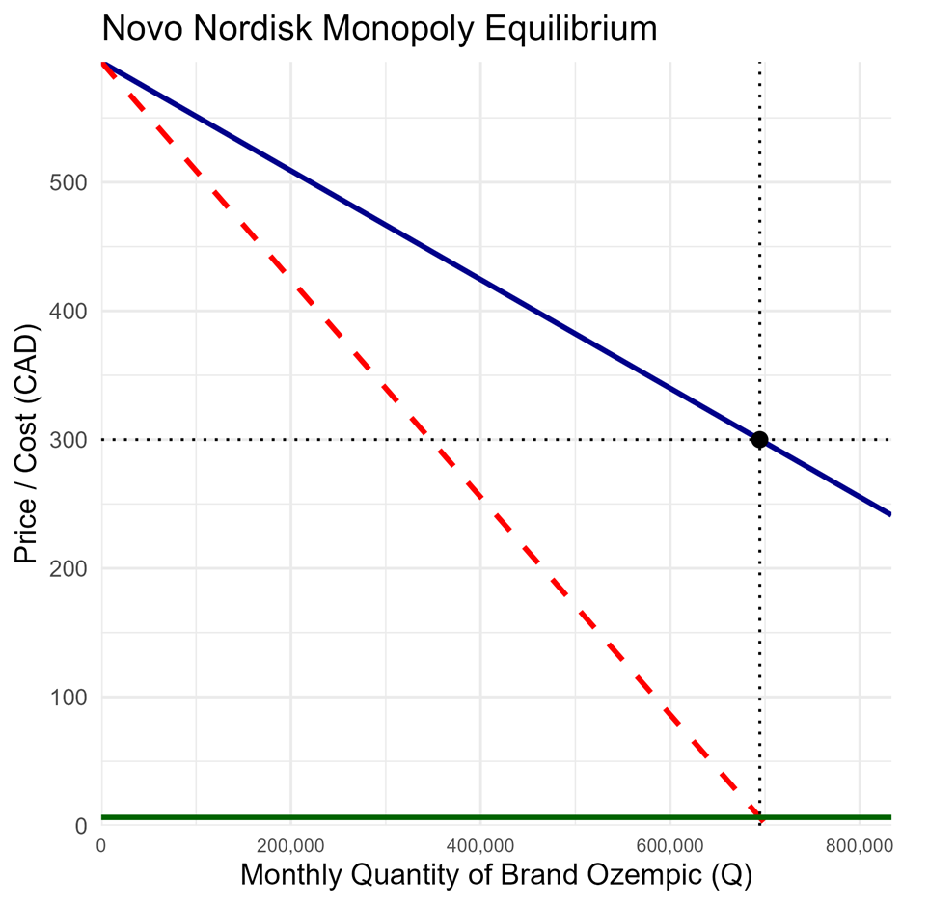
O
D(Q_{O}) =$\text{593.5 – 0.000042264Q}$
MR(Q_{O})
MC(Q_{O}) = $6.5
Q_{O}* = 694,444
P_{O}* = $300
To verify the plausibility of the model demand, the quantity demanded when $P_{O}=0$ can be solved, yielding $Q_{O}=1,404,268$. This implies that if the price of Ozempic were hypothetically $0, then approximately $1,404,268$ Canadians would demand it each month. It was calculated in the introduction that around $2,595,420$Canadians have been diagnosed with type-2 diabetes by their physician. Many of them would either be taking another drug or do not want to be on Ozempic. Therefore, the $1,404,268$ figure does not seem implausible with reference to type-2 diabetes. Nonetheless, it does seem to drastically underestimate the quantity of Canadians who would demand it for weight loss if the drug were offered at such a low price. By consequence, it will be important to set a substantial growth rate for Ozempic demand within the long-run equilibrium model at $t=2$.
There are a few key statistics that can be drawn from the monopoly model.
Firstly, the Lerner Index, as a measure of market power, can be calculated as $L=\frac{P-MC}{P}$. In the case of Novo Nordisk in Canada, $L=\frac{\$300-\$6.5}{\$300}=0.9783$. Given the $0≤L≤1$, with 1 in the case of a pure monopoly, Novo Nordisk’ s $L=0.9783$ demonstrates a high degree of market power during its period of market exclusivity. In fact, the pharmaceutical monopolist is setting its price over 46 times larger than its marginal cost.
Secondly, the elasticity of demand can be measured at the profit-maximizing price. It is given by $ε_{1}=\frac{dQ_{O}}{dP_{O}}\frac{P_{O}^{*}}{Q_{O}^{*} }=-\frac{1}{b}\frac{P_{O}^{*}}{Q_{O}^{*}}=-\frac{1}{0.000042264}×\frac{300}{694,444}=-1.022$. Since the monopolist will always produce on the elastic portion of demand, this figure is to be expected, and it is very close to unitary elasticity.

Model $t=1$: Monopoly with Generics Paradox
In the original monopoly model, at the point $\left(Q_{O}^{*},P_{O}^{*}\right)=(694,444,\$300)$, it was determined that the price elasticity of demand is $-1.022$. Therefore, assuming that generics enter the market in 2026 and consume a portion of market share, then the price elasticity of demand facing Novo Nordisk at $P_{O}=\$300$will fall (become more inelastic). From the literature, Ching found that price elasticity will fall to 0.76 to 0.82 within one year after generic entry (2010). This will become the basis for the range of possible $ε_{2}$ values assumed at $P_{O}=\$300$. A scenario analysis will be performed, allowing $ε_{2}$ to take on the elasticates in the range ${|ε}_{2}|∈[0.75, 1.00]$. The share of generics within the market, $α$, will be allowed to assume values $α∈[0.1,0.7]$, covering the various figures cited in literature. It is important to note that the assumed elasticity is not the elasticity occurring at the new equilibrium, but as aforementioned, the elasticity at the profit-maximizing price in the $t=-1$ model. At the new equilibrium, demand will necessarily be elastic, since a monopolist will only produce along the elastic portion of its demand.
Figure 2: Novo Nordisk Equilibrium Price Under Generic Paradox, Varying Elasticities
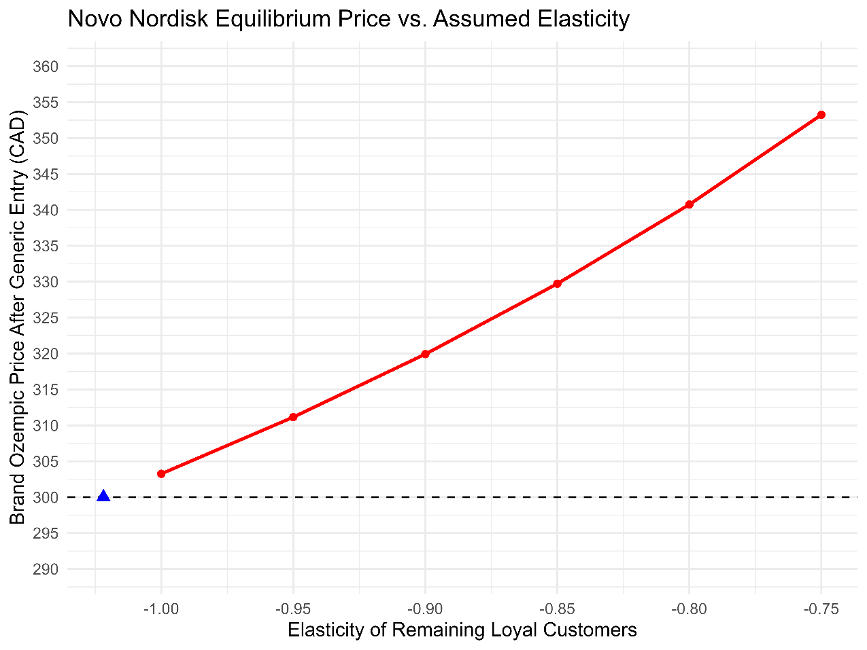
+3.71%
+17.75%
+13.58%
+9.91%
+6.64%
If remaining loyal consumers have a lower price elasticity, then the generics paradox is visible. The model predicts that Novo Nordisk could raise its price to anywhere between $303.25 (or 1.08% higher than present) and $353.25 (or 17.75% higher than present) once generics begin penetrating the market. The relationship between assumed elasticity and the degree of generic paradox is evident: if remaining customers have increasingly higher inelasticity (lower elasticity) due to brand loyalty, Novo Nordisk will be able to raise its prices increasingly higher. This is intuitive, given that inelastic consumers are less likely to shift to cheaper-priced generics and will be willing to remain with brand Ozempic despite higher prices. It is interesting to note that this is irrespective of the generic market share; under an assumed elasticity, any generic market share will yield the same rise in price.
Figure 3: Novo Nordisk Equilibrium Quantity Under Generic Paradox, Varying Elasticities and Generic Market Share
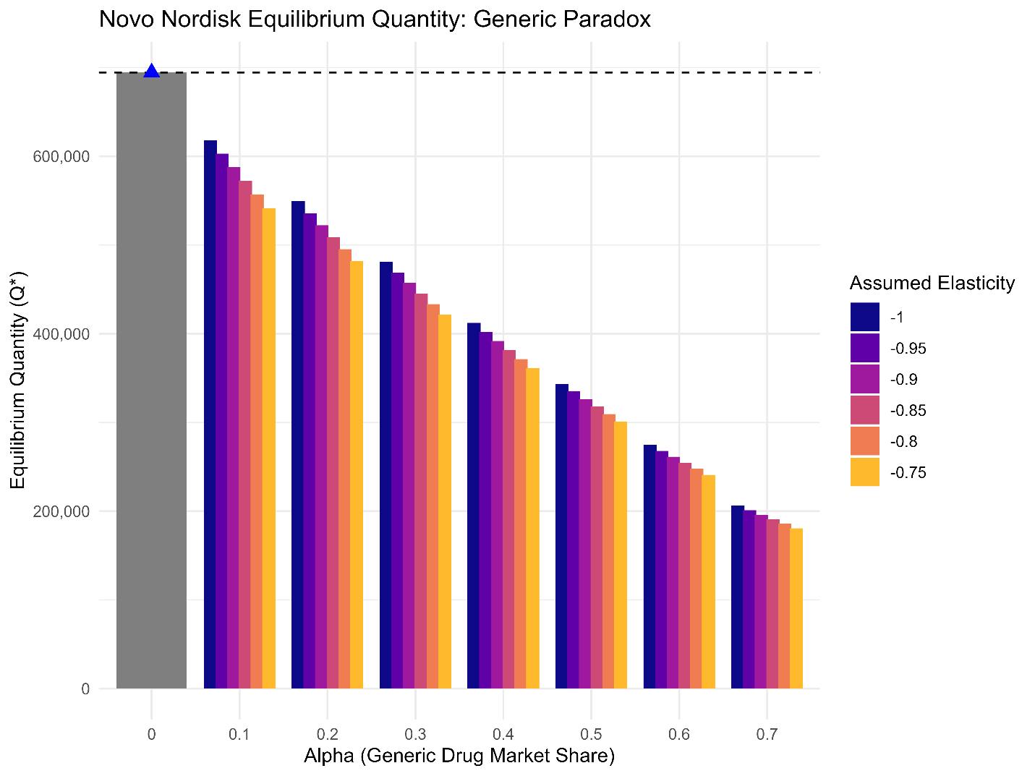
Naturally, as the market share of generics increases in the short run, under the assumption that there is no short-term growth in total demand, the quantity of brand Ozempic will fall. If generics penetrate 10% of the market, the total drop in demand will moderate (between approximately 11% and 22%); however, if the generics penetrate even 50% of the market, the total drop will be rather precipitous (between approximately 51% and 57%). It is unlikely that generic will gain more than a 50% market share in the short run; however, in that case, Novo Nordisk’s output would be even further reduced. Based on the literature, a prediction would be made that the short-term equilibrium may observe generics obtaining between a 10% to 20% market share, thereby reducing Novo Nordisk’s output of Ozempic to between roughly 500,000 and 600,000 units per month. Nonetheless, what provides greater insight into the generics paradox is the impact of assumed elasticity. For a given generics market share, if the remaining demand for brand Ozempic becomes less elastic, then the quantity supplied will fall further. This is the direct result of Novo Nordisk’s monopolist power, where it is raising prices and reducing output in order to maximize its profits. Interestingly to note, the larger the generic market share, the less Novo Nordisk will be able to reduce its quantity, and the impact of assumed elasticity weakens.
Below is a base-case postulation of one hypothetical model, building on the literature review from previous observations. In particular, $α=0.1$. This aligns with the literature on the higher end of estimated generic market penetration after approximately one year’s time. The assumption being made here is that the generics paradox will only be observed in the near future, but in reality, it may also be observed for additional years. Furthermore, the assumed elasticity at the price $P_{O}=\$300$ will be $ε_{2}=-0.8$. This aligns with the figures estimated by Ching (2010), and is relatively high inelasticity, given that brand Ozempic currently has a very loyal following. Under these assumptions, the new market demand for brand Ozempic can be derived, and Novo Nordisk will now monopolistically maximize its profit based on this demand.

Figure 4: Base Case Short Run Equilibrium for Brand Ozempic Following Generic Entry
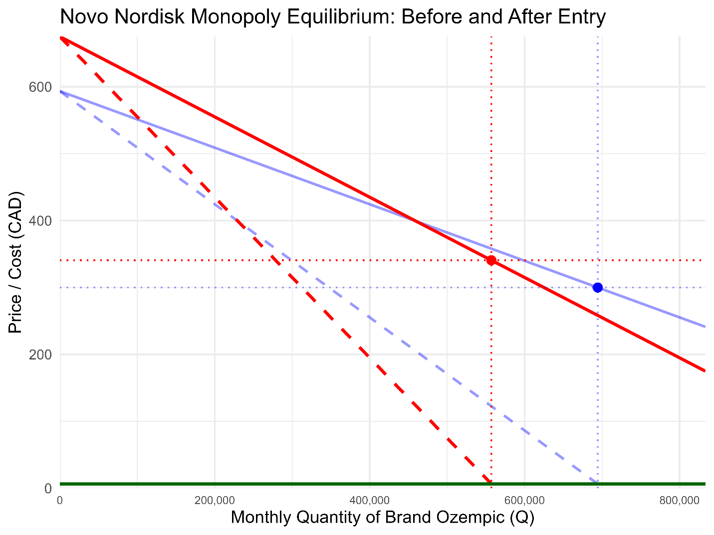
D(Q_{O})
MR(Q_{O})
MC(Q_{O}) = $6.5
Q_{O}* = 694,444
P_{O}* = $300.00
D₂(Q_{O})
MR₂(Q_{O})
Q_{O}*’ = 557,083
P_{O}*’ = $340.75
O
A 13.58% increase in the price of Ozempic is quite high, surpassing the rates observed by Vandoros & Kanavos across Europe (2013). Nevertheless, this brand price increase is not implausible, given that Ozempic has so firmly entrenched itself within society. There is bound to be a larger group of individuals remaining loyal to the brand, and willing to pay the additional fee if they perceive it to be more effective or reputable than the generics. It is also important to note that Ozempic is covered under many provincial public health insurance plans, which reduces the elasticity of demand in general. Since there will be a lag in physicians pivoting from brand Ozempic to its generics, those covered by the insurance will make no strides to hasten the switch to the generics either.

Model $t=2$: Competitive Fringe Model with Dominant Firm
A comprehensive scenario analysis was conducted for the long-run equilibrium. Five different elements of the model were allowed to vary:
- $MC_{i}\left(q_{fi}\right)$: the marginal cost of the generics. It was assumed to be of the form $MC_{i}\left(q_{fi}\right)=c+dq_{fi}$, as aforementioned. Values of $c$ could range within $c∈[3.5,7.5]$, assuming that it would not differ drastically from Novo Nordisk’s constant marginal cost with $c=6.5$. Values of $d$ could range within $d∈(0,0.05]$. While in reality, a value $d=0$ should be attainable for generics, as they reach economies of scale like Novo Nordisk, this is not mathematically possible within the competitive fringe model. Hence, values were taken strictly larger than 0. As discussed thoroughly within the model assumptions section, the base case scenario marginal cost for individual generics will be $MC_{i}(q_{fi})=6.5+0.001q_{fi}$, where they have roughly the same marginal cost as Novo Nordisk, but increasing their production by 1,000 units will raise the marginal cost by a dollar.
- $g$: the yearly growth rate of demand. Total demand facing the brand and generic Ozempic market in the long run is subject to a yearly growth rate. That is, $D\left(Q_{O}\right)=a{\left(1+g\right)}^{yrs}-bQ_{O}$. The entire demand will shift outwards at the growth rate. Given the growth rate CAGR of 10.1% per year for semaglutide drugs projected by analysts over the next seven years, values of g could range within $g∈[0,0.2]$, taking into account potential for higher or lower growth. 20% growth would be a vast overestimation for the number of years it takes to reach the long-term equilibrium, although Ozempic has in fact been growing at a rate of similar magnitude within Canada over recent years. The base case scenario growth estimate will align precisely with the analyst expectation: $g=10\%$.
- $yrs$: the approximate number of years it takes to reach the steady state (used in complement to the growth rate). The number of years it takes for the generics to settle at a consistent market share varies by drug; in some generic penetration is rapid, while in others it is prolonged. For the scenario analysis, the number of years could range within $yrs∈[0,12]$. Again, 12 is an overestimation, since literature suggests it often reaches an equilibrium point in six to eight years. Therefore, in the base case scenario, $yrs=8$.
- $n$: the number of generic firms. For mathematically logical values within the model, the number of generic firms must be at least 2. The fringe model works best when the fringe has multiple competitive firms. Again, across the literature, this figure changes drastically between drugs. Already, at least five announcements have been made by firms intending to produce a semaglutide generic in Canada. While some of these may fall through at the government approval stage, more likely than not, additional firms will enter. Since Ozempic is considered a “blockbuster drug”, literature suggests there will be a much larger number of firms. The average number for large drugs is 7.2 (Grabowski and Kyle, 2007); however, given the popularity of Ozempic, a figure higher than this is probably. Therefore, the number of generic entrants in the long run could range from $n∈[0,20]$, but in the base case scenario $n=8$, slightly above the general average for blockbuster drugs.
- $P_{C}$: the addition of a Government of Canada and PCPA-negotiated generics price ceiling. Under the base case scenario, it is assumed that there is no generic price ceiling. Any precise estimate for the magnitude of the regulation is difficult to gauge, as even for existing drugs, this information is not readily available. Instead, the price ceiling is given a large range to account for nearly all possibilities, $P_{C}=[10,200]∪∅$. Realistically, the price ceiling would likely be moderate. According to the PCPA, in the case where there are many generics and the drug is injectable, generics should be negotiated in price down to around 35% of the original brand-name drug, which equates to $105 in the case of Novo Nordisk’s Ozempic (PCPA, 2025). Rounding down, in the base case scenario with an imposed price ceiling, the assumption will be $P_{C}=\$100$.
The entire results of the scenario analysis can be found in the interactive R Shiny model; please refer to the full data visualization and in-depth presentation of the results: https://edwynnturnerhc-sc-gc-ca.shinyapps.io/Interactive_App_ECO_4139/
To begin, the base case scenario will be briefly explored. Based on the literature and the construction of the model, this base case is estimated to be the most likely scenario within the Canadian semaglutide market in the long run.
Figure 5: Base Case Scenario Competitive Generic Fringe with Dominant Novo Nordisk
$$D(P_{O})$$
$$MR_{NN}(Q_{NN})$$
$MC_{NN}(Q)$=$6.5
$Q_{NN}^{*}=1.497$ million
$$P*=\$150.95$$
$$D_{NN}(P_{O})$$
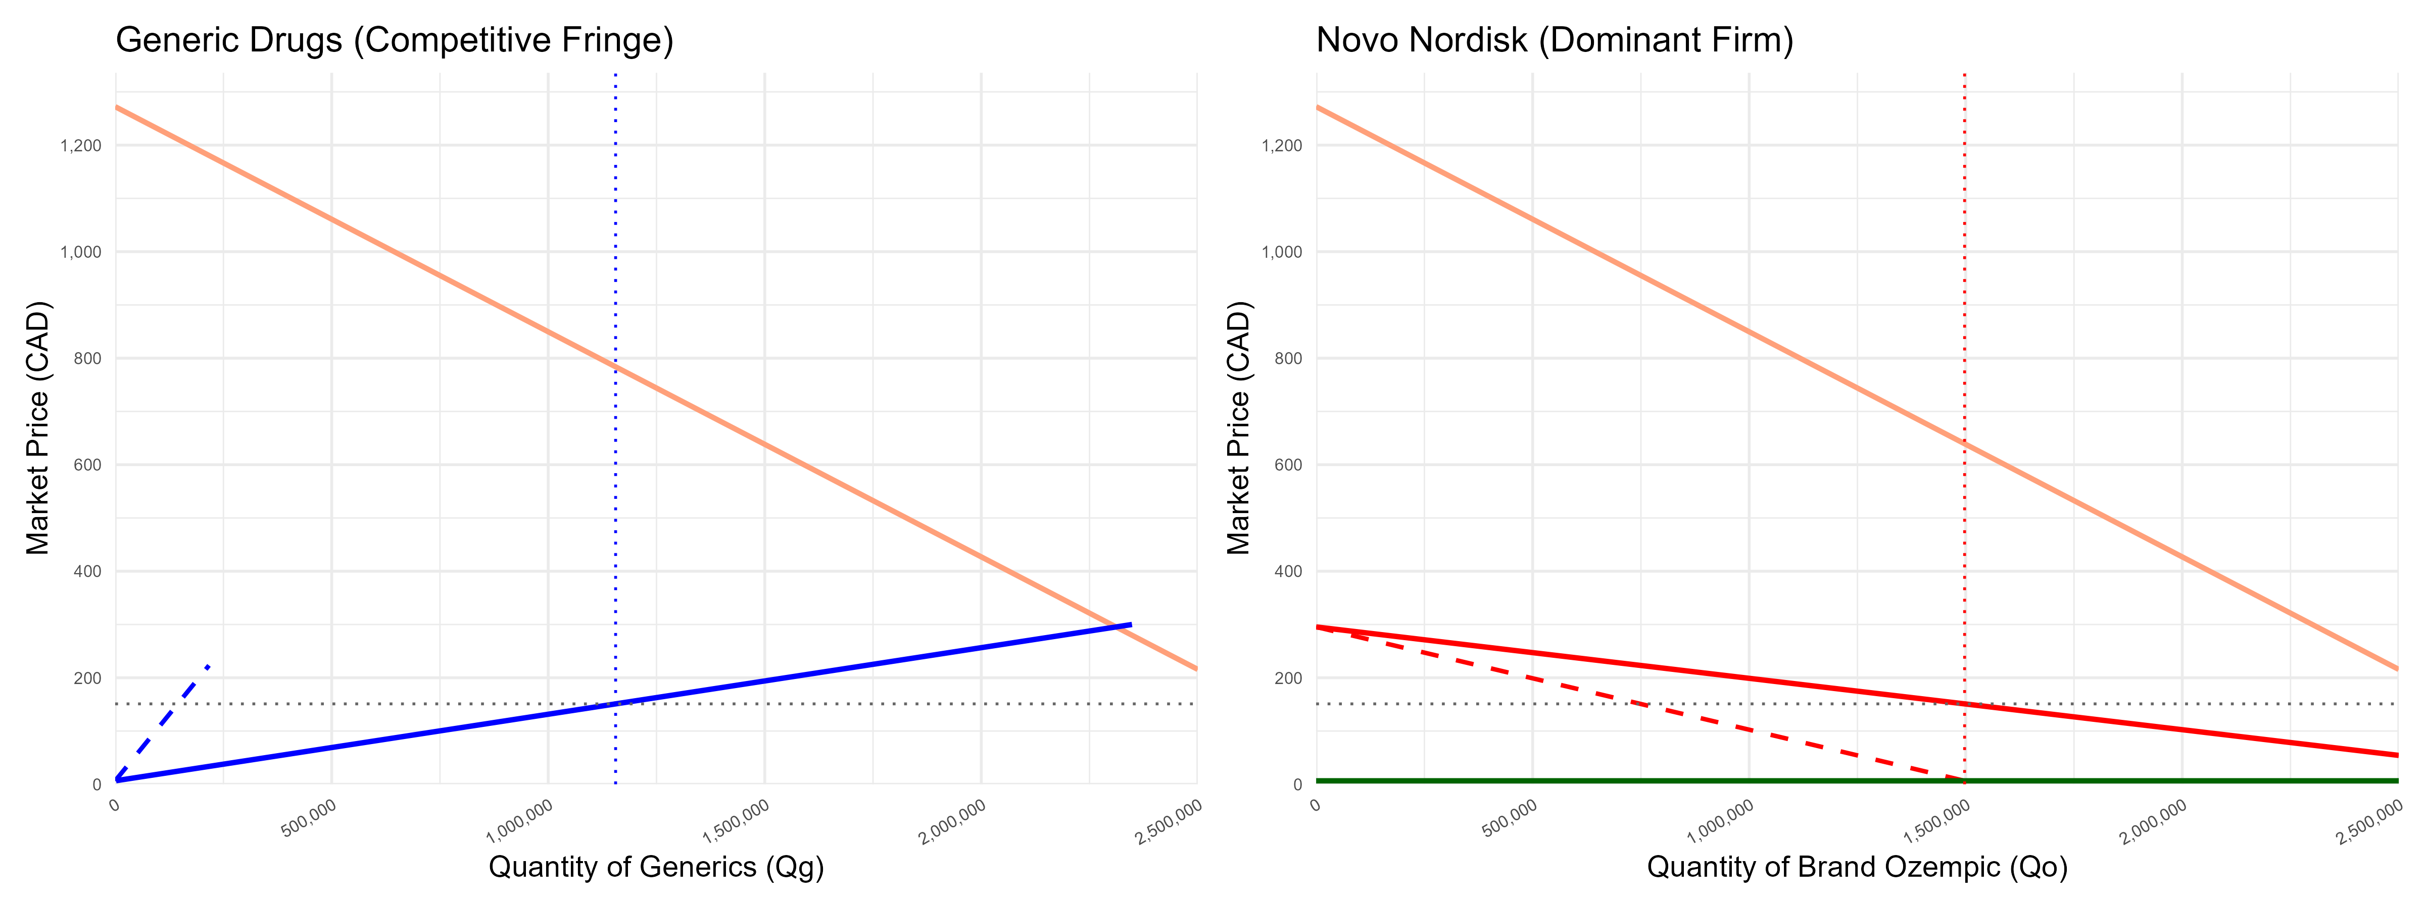
$$P_{O}^{*}=\$150.95$$
${MC}_{i}(q_{fi})$
$S_{f}(P_{O})$
$$D(P_{O})$$
Under the base case scenario, the market price of semaglutide drugs is projected to have fallen by 49.7% relative to the original monopolist price, from $300 down to $150.95. Novo Nordisk is forecasted to maintain a 56.4% market share, selling 1,497,396 units of brand Ozempic per month, while all eight generics combined are forecasted to hold the remaining 43.6% of the market share, selling 1,155,613 monthly units of semaglutide biosimilars or bioequivalents. Total market output is 2,553,009, which is 3.68 times larger than it was under the $t=-1$monopoly. Such figures coincide with literature discussing ranges of market share and pricing. Keeping all other variables the same, but allowing the number of generic firms, $n,$ to vary reveals the relationship between long-run equilibrium price and the saturation of generics in the market (see Figure 6 below).
Figure 6: Long-run Equilibrium Model with Varying Number of Generic Producers
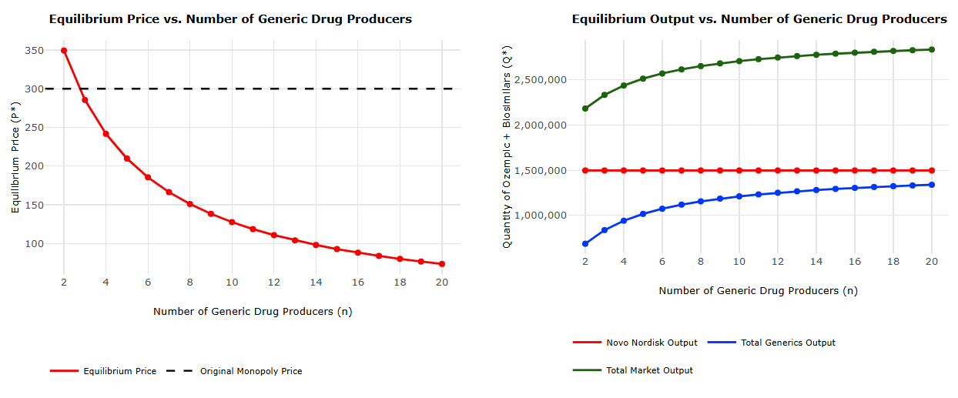
As the quantity of generics increases, the long-run market price for semaglutide drugs in Canada will fall. With only 4 generic producers in the long run, the equilibrium price is projected to be $241.71 (or a fall of 19.4%), but if up to 15 generic producers enter the market, the equilibrium price will be $92.73 (or a fall of 69.1%). While purely negative monotonic, the rate at which the price falls is decreasing with the addition of each new producer; that is, the curve is concave upwards. Naturally, with a larger number of generic producers, the total quantity of brand and generic drugs in Canada will grow. Since all other variables are kept the same, Novo Nordisk will not alter its profit-maximizing output regardless of the number of generic producers; however, the generic market share will rise. Under the $n=4$ scenario, the generic market share is only 38.6%, but under the $n=15$scenario, it has increased to 46.3%. In the base case scenario, generic producers are assumed to have a higher marginal cost when increasing their output, since they have yet to reach economies of scale. However, if this assumption is relaxed and now each generic producer faces a marginal demand $C_{i}(q_{fi})=6.5+0.00005q_{fi}$ ($1 increase in marginal cost for every 20,000 units manufactured), then the price will fall even further. This is a possible forecast to make, as it assumes that generic producers will be able to achieve economies of scale in the future, as is the case with Novo Nordisk.
Figure 7: Long-Run Equilibrium Model with Lower Generic Marginal Costs
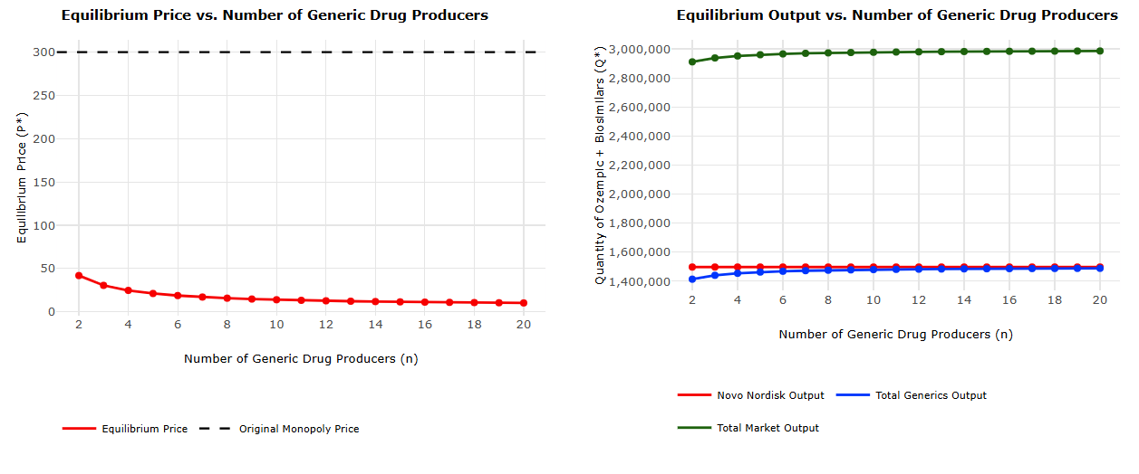
Under this (rough) economies of scale model for the generics, the long-run equilibrium price will fall to $15.72 when $n=8$, and $12.68 when $n=12$. This is now only slightly higher than marginal cost, yielding a Lerner index of only $L=\frac{P-MC}{P}=0.49$to $0.59$ for Novo Nordisk. While this low price is entirely feasible within certain drug markets and is a possibility within the semaglutide market, this scenario is still unlikely to be the case for such a large and popular drug as Ozempic. Vondeling et. al found across their literature review that the lowest observed long-run equilibrium price was 6.6% of the original brand price (2018). Nonetheless, 6.6% of $300 is $19.80, and the Ozempic brand is particularly strong; hence, any price lower than this is improbable. Market share for generics will be roughly equivalent to the market share for Novo Nordisk once $n≥10$. Under most models within the scenario analysis, generic producers will not obtain higher than a 50% market share, which is realistic and falls within the common 40% to 60% range described in the literature. However, there is empirical evidence from the literature that generic market shares may occasionally rise above 60%. This observation is possible in the model, but only if an assumption is made that $c<6.5$ (with $d≈0)$ within the individual generic supply curves $C_{i}(q_{fi})=c+dq_{fi}$. For example, letting $c=5.5$, and maintaining $d=0.00005$ from above, generics could reach up to a 56.6% market share. Lastly, assuming the federal government and the Pan-Canadian Pharmaceutical Alliance negotiate price controls, capping prices of generics at $100, Novo Nordisk may benefit from higher prices even in the long run. All other base case scenario assumptions from above will be kept the same.

Figure 8: Long-Run Equilibrium Model with $100 Generics Price Regulation
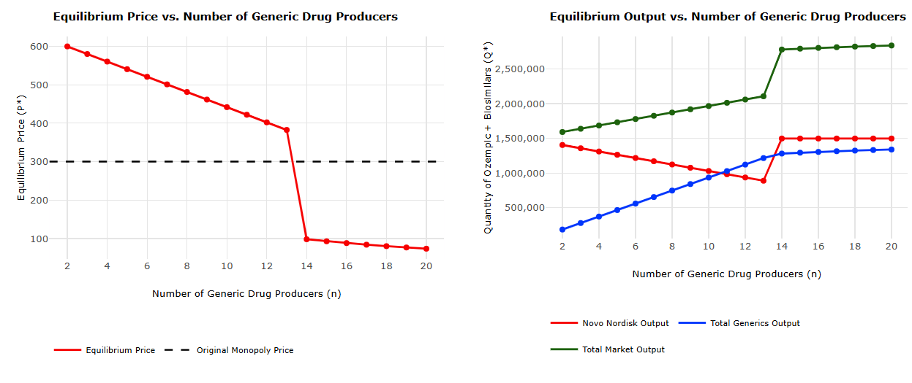
The kink when the price ceiling becomes binding, based on the number of generics in the market, is evident in Figure 8. When $n≤13$, the price ceiling is binding; generic producers as price takers will sell their drugs for $100 in accordance with the regulation. Novo Nordisk will now be faced with a much greater residual demand, since the entire generic supply will be limited. Hence, price would be able to surpass the $t=-1$ model since an assumption of large growth ($g=10\%)$ has been applied. This aligns with the research of Ekelund & Persson, who concluded that government regulation in the pharmaceutical industry may in fact contribute to rising prices (2003). Cumulatively, Novo Nordisk is now in fact subject to a higher demand in the long run, even in the face of generic competitors, than it was before its loss of exclusivity. As the number of generics rises, their total supply will rise as well, despite the price ceiling, driving down Novo Nordisk’s residual demand and thus its profit-maximizing output. Once $n≥14$, Novo Nordisk’s profit-maximizing price would fall below $100, thereby rendering the price ceiling non-binding. Now, the model is identical to the base case scenario. The model can equally be used to analyze the impact the demand for Ozempic will have on price and market share. If demand grows by less than expected ($g<10\%)$, prices will fall to lower values. On the contrary, if demand grows by more than expected ($g≫10\%$), it is possible that Novo Nordisk’s prices will in fact not fall in the long run, but will be above $300. This coincides with the findings of Frank & Salkever (1991).

Conclusion
The dynamics within the Canadian semaglutide market for type-2 diabetes and weight-loss vary drastically over time. Currently, Novo Nordisk, the sole producer of Ozempic, acts as a statutory monopoly and exhibits a high degree of market power. This is observable through its Lerner Index of 0.9873 and its ability to set its price over 46 times its marginal cost. The brand Ozempic patent is slated to expire in January 2026 in Canada, the first of this occurrence in the world, and the market structure will thereafter shift as generic drugs penetrate the market. Due to a high level of inertia and brand loyalty in the short run, Novo Nordisk will maintain market power even in the face of its bioequivalents and biosimilars, still acting as a monopolist. In a phenomenon known as the “generic paradox”, the most price-elastic consumers will shift to generics, leaving those who are price-inelastic with brand Ozempic. In turn, this may result in a rise in brand price. The model suggests this could range from about 6.64% to 17.75% increases in the short run, most likely around 13.58%. In the long run equilibrium, Novo Nordisk will lose some market power, since consumers will have full access to information, thereby making them more price elastic. By consequence, in order to maintain competitiveness, Novo Nordisk will have to lower its Ozempic price, likely by a drastic amount. The long run is modelled by a competitive fringe with a dominant firm, since Novo Nordisk still has some power over its price setting, while generics will roughly act as price takers. Under the most likely base case scenario, the market price will fall to around $150.95, which is just over 50% of the original monopolist price. It is predicted that generic market share will likely be around 45% ; however, the more generics that are in the market, the lower the market price and the higher the market share of generics. Additionally, the model suggests that lower marginal cost for the generics will greatly lower the price, even to below $15.00, and raise the generic market share. The imposition of a generics price ceiling, while guaranteeing the price of generics will be lower, may also limit their supply, thereby allowing Novo Nordisk to again raise its prices. Lastly, long-term growth in demand for Novo Nordisk has a significant impact on the equilibrium price. Low growth will allow for prices to fall drastically with generic entry, while high growth will partially offset this, or even result in rising prices in the future if it is large enough in magnitude. The model explored within the paper has many limitations. Foremost, a static model was employed for a dynamic process that changes over time. Econometric models are more often employed within research of generic market entry, capturing the gradual fall of prices in response to more generic producers, coupled with shifting consumer loyalties. Nonetheless, given the lack of any historical pricing data for Ozempic, it is unlikely that reliable econometric models could be used in the forecasting process. Instead, this will undoubtedly be a topic of research in the future, reviewing the impacts of Novo Nordisk’s patent expiration in hindsight. Congruently, the largest limitation of the study arises in the form of data collection. Due to the secrecy of pharmaceutical practices, no reliable data for Ozempic in Canada has been released. All figures were derived from analyst speculations. For example, the price of $300 in itself was an estimate derived from four different news articles; had a slightly different price been selected, the variability of results would have been drastic. Therefore, as an extension, a scenario analysis could be conducted not only on theoretical assumptions, but also on the data assumptions as well. Further, a notable limitation of this model was the lack of a brand price ceiling in the $t=-1$ model. The only way to derive a market demand curve from the limited data was to solve the system assuming the current market price and quantity are the profit-maximizing price and quantity, respectively. Nonetheless, in reality, the current market price and quantity are likely those restricted by a PMPRB-imposed price control. In this case, there would be no means to simply derive the market demand; hence, requiring a significant assumption to be made. Other major assumptions, such as the treatment of only one form of consumer, are unrealistic. As an important extension to this existing model, multiple demand curves could be included, perhaps referring to those who are covered under health insurance and those who are not, as used by Kong (2009), or even those taking Ozempic for weight loss and those taking it for type-2 diabetes. While the paper makes predictions of prices and quantity of Ozempic in the Canadian market, it is important to reflect upon the impact this may have on consumers. Although using Ozempic for weight loss could be considered discretionary, many people also rely on the drug to treat the chronic illness of type-2 diabetes. Therefore, market dynamics have direct implications for the health and well-being of the Canadian population. Viewing this solely from a numerical economic perspective is perhaps slightly reductionist, as it does not put enough emphasis on individual health. If generic penetration is able to reduce prices while simultaneously increasing the total quantity available in the market, then this will have a larger positive impact on consumer surplus. While Novo Nordisk’s Canadian Ozempic profit is forecasted to plummet, as its margins are reduced by at least half, this will likely be to the benefit of the general public. The federal and provincial governments can catalyze generic penetration by introducing incentives and removing barriers to entry, in turn assuring greater drug affordability for Canadians.

References
Adam, Jules (2025) “Did Novo Open the Canadian Market to GLP-1 Generics?”, Labiotech. Retrieved from https://www.labiotech.eu/in-depth/novo-nordisk-semaglutide-patent -expiration-canada/
Aronsson, Thomas, Mats A. Bergman, and Niklas Rudholm (2001) “The Impact of Generic Drug Competition on Brand Name Market Shares–Evidence from Micro Data,” Review of Industrial Organization 19(4), 423-433
Bank of Canada (2025) “Annual Average Exchange Rates,” Bank of Canada. Retrieved from https://www.bankofcanada.ca/rates/exchange/annual-average-exchange-rates/
Bergman, Mats A., and Niklas Rudholm (2003) “The Relative Importance of Actual and Potential Competition: Empirical Evidence from the Pharmaceuticals Market,” The Journal of Industrial Economics 51(4), 455-467
Berndt, Ernst R., Richard Mortimer, Ashoke Bhattacharjya, Andrew Parece, and Edward Tuttle (2007) “Authorized Generic Drugs, Price Competition and Consumers’ Welfare,” Health Affairs 26(3), 790–9
Bhattacharya, Jayanta, and William B. Vogt (2003) “A Simple Model of Pharmaceutical Price Dynamics,” Journal of Law and Economics 46(2), 599-626
Billingsley, Alyssa, and Christina Aungst (n.d.) “GLP-1 Agonists – Ozempic Alternatives,” GoodRx. Retrieved from https://www.goodrx.com/classes/glp-1-agonists/ozempic alternatives?srsltid=AfmBOoqZknxTscxwod8Ktk9BTYT_vvE P0E_1v_DKfzMRKrVOoY7c36p
Blank, Larry, David L. Kaserman, and John W. Mayo (1998) “Dominant Firm Pricing with Competitive Entry and Regulation: The Case of IntraLATA Toll,” Journal of Regulatory Economics 14(1), 35-53
Canadian Institute for Health Information (2023) “Canada’s public-drug program spending reaches $184 billion in 2023 — medications like Ozempic driving,” CIHI.ca. Retrieved from https://www.cihi.ca/en/news/canadas-public-drug-program-spending-reaches-184- billion-in-2023-medications-like-ozempic-driving
Canadian Medical Association (n.d.) “Why It’s So Hard to Find a Family Doctor,” CMA.ca. Retrieved from https://www.cma.ca/healthcare-for-real/why-it-so-hard-find-family-doctor
CBC News (2023) “How Ozempic works in B.C. as demand soars,” CBC. Retrieved from https://www.cbc.ca/news/canada/british-columbia/ozempic-canada-british-columbia- how-it-works-1.6794950
Ching, Andrew T. (2010) “Consumer Learning and Heterogeneity: Dynamics of Demand for Prescription Drugs After Patent Expiration,” International Journal of Industrial Organization 28(6), 619-638
Christou, Charalambos, and Constantinos G. Papadopoulos (2015) “The Countervailing Power Hypothesis in the Dominant Firm-Competitive Fringe Model,” Economics Letters 126, 110-113
Coherent Market Insights (2025) “Ozempic Market Report,” Coherent Market Insights. Retrieved from https://www.coherentmarketinsights.com/industry-reports/ozempic- market
Constantino, Annika K. (2024) “Ozempic Can be Made for Less Than $5 a Month, Study Finds,” CNBC. Retrieved from https://www.cnbc.com/2024/03/27/novo-nordisk-ozempic-can-be- made-for-less-than-5-a-month-study.html
Dalen, Dag M., Steiner Strøm, and Tonje Haabeth (2006) “Price Regulation and Generic Competition in the Pharmaceutical Market,” The European Journal of Health Economics 7(3), 204-211
Duflos, Gautier, and Frank R. Lichtenberg (2011) “Does competition stimulate drug utilization? The impact of changes in market structure on US drug prices, marketing and utilization,” International Review of Law and Economics 32(1), 95-109
Ekelund, Mats, and Björn Persson (2003) “Pharmaceutical Pricing in a Regulated Market,” Review of Economics and Statistics 85(2), 298-306
Frank, Richard G., and David S. Salkever (1991) “Pricing, Patent Loss and the Market for Pharmaceuticals,” Southern Economic Journal 59(2), 165-179
Frank, Richard G., and David S. Salkever (1997) “Generic Entry and the Pricing of Pharmaceuticals,” Journal of Economics & Management Strategy 6(1), 75-90
Gorecki, Paul K. (1987) “Barriers to Entry in the Canadian Pharmaceutical Industry: Comments, Clarification and Extensions,” Journal of Health Economics 6(1), 59-72
Grabowski, Henry G., and Margaret Kyle (2007) “Generic Competition and Market Exclusivity,” Managerial and Decision Economics 28(4), 491–502
Grepperud, Sverre, and Pål A. Pedersen (2020) “Positioning and Negotiations: The Case of Pharmaceutical Pricing,” European Journal of Political Economy 62, 101853
Grootendorst, Paul, Ron Bouchard, and Aidan Hollis (2012) “Canada’s Laws on Pharmaceutical Intellectual Property: The Case for Fundamental Reform,” Canadian Medical Association Journal 184(5), 543–549
Hansen, Lars P., and Thomas J. Sargent (2003) “Robust Control of Forward-Looking Models,” Journal of monetary Economics 50(3), 581-604
Health Canada (2017) “Consultation — Regulations for Patented Medicines,” Government of Canada. Retrieved from https://www.canada.ca/en/health-canada/programs/consultation regulations-patented-medicine/document.html
Innovation, Science and Economic Development Canada (2025) “Pharmaceutical-Industry Profile,” Government of Canada. Retrieved from https://ised- isde.canada.ca/site/canadian-life-science-industries/en/biopharmaceuticals-and- pharmaceuticals/pharmaceutical-industry-profile
Ito, Yuki, Konan Hara, and Yasuki Kobayashi (2020) “The effect of inertia on brand-name versus generic drug choices,” Journal of Economic Behavior & Organization 172, 364-379
Jelovac, Izabela (2015) “On the Relationship Between the Negotiated Price of Pharmaceuticals and the Patients’ Co-Payment,” Economics Bull 35, 481-93
Karamali, Kamil (2025) “Ozempic Set to Become More Affordable, Accessible in Canada Raising Concerns of Drug Abuse,” CTV News Canada. Retrieved from https://www.ctvnews.ca/canada/article/ozempic-set-to-become-more-affordable accessible-in-canada-raising-concerns-of-drug-abuse/
Kong, Ying (2004) “The Price Premium of Generic to Brand-Names and Pharmaceutical Price Index,” Applied Economics 36(7), 731–737
Kong, Ying (2009) “Competition Between Brand‐name and Generics–Analysis on Pricing of Brand‐name Pharmaceutical,” Health Economics, 18(5), 591-606
Lowe, Derek (2025) “Novo Nordisk’s Canadian Mistake,” Science.org. Retrieved from https://www.science.org/content/blog-post/novo-nordisk-s-canadian-mistake
Ma, Jason (2025) “Novo Nordisk May Face Patent-Protection Fees for Ozempic and Wegovy in Canada,” Fortune. Retrieved from https://fortune.com/2025/06/17/novo-nordisk- ozempic-wegovy-semaglutide-canada-patent-protection-fee/
Magazzini, Laura, Fabio Pammolli, and Massimo Riccaboni (2004) “Dynamic Competition in Pharmaceuticals,” European Journal of Health Economics 5(2), 175–82
Maple (2024) “How Much Does Ozempic or Semaglutide Cost in Canada?,” GetMaple,ca. Retrieved from https://www.getmaple.ca/blog/semaglutide-ozempic-cost-in-canada/
Maple (2024) “How to Get Ozempic Prescribed for Weight Loss in Canada,” GetMaple.ca. Retrieved from https://www.getmaple.ca/blog/how-to-get-ozempic-prescribed-for- weight-loss-in-canada/
McRae, James J., and Francis Tapon (1985) “Some Empirical Evidence on Post-Patent Barriers to Entry in the Canadian Pharmaceutical Industry,” Journal of Health Economics 4(1), 43-61
Nguyen, Nguyen Xuan , Steven H. Sheingold, Wafa Tarazi, and Arielle Bosworth (2022) “Effect of Competition on Generic Drug Prices,” Applied Health Economics and Health Policy 20(2), 243-253
Pan-Canadian Pharmaceutical Alliance (2023) “Generic Drug Framework: Overview,” PCPA Canada. Retrieved from https://www.pcpacanada.ca/generic-drug- framework#:~:text=Overview,annually%20from%202014%20to%202017
Patented Medicine Prices Review Board (n.d) “Guidelines for PMPRB,” Government of Canada. Retrieved from https://www.canada.ca/en/patented-medicine-prices review/services/legislation/guidelines.html
Peter A. Allard School of Law (2024) “Prescription-Drug Patents in Canada,” UBC. Retrieved from https://iplaw.allard.ubc.ca/2024/04/01/prescription-drug-patents-canada/
Public Health Agency of Canada (2022) “Framework for Diabetes in Canada: Infographic,” Government of Canada. Retrieved from https://www.canada.ca/en/public health/services/publications/diseases-conditions/framework-diabetes-canada infographic.html
Santos, Joshua (2025) “‘The Potential is Phenomenal’: Drug-Maker Vimmy Pharma Plans to Produce Made-in-Canada Generic Ozempic,” BNN Bloomberg. Retrieved from https://www.bnnbloomberg.ca/business/economics/2025/10/17/the-potential-is- phenomenal-drug-maker-vimmy-pharma-plans-to-produce-made-in-canada-generic- version-of-ozempic/
Scott Morton, Fiona M., Ariel D. Stern, and Scott Stern (2018) “The Impact of the Entry of Biosimilars: Evidence from Europe,” Review of Industrial Organization 53(1), 173-210
SingleCare (2024) “Ozempic from a Canadian Pharmacy: What to Know,” SingleCare. Retrieved from https://www.singlecare.com/blog/ozempic-canadian-pharmacy/
Starc, Amanda, and Thomas G. Wollmann (2025) “Does Entry Remedy Collusion? Evidence from the Generic Prescription Drug Cartel,” American Economic Review 115(5), 1400- 1438
Statista (n.d.) “Number of Canadians reporting being diagnosed with diabetes.” Retrieved from https://www.statista.com/statistics/434090/number-of-canadians-reporting-being- diagnosed-with-diabetes/
Suh, Dong C., Willard G. Manning, Stephen Schondelmeyer, and Ronald S. Hadsall (2000) “Effect of Multiple-Source Entry on Price Competition After Patent Expiration in the Pharmaceutical Industry,” Health Services Research 35(2), 529–547
Tenn, Steven, and Brett Wendling (2014) “Entry Threats and Pricing in the Generic Drug Industry,” Review of Economics and Statistics 96(2), 214-228
Vandoros, Sotiris, and Panos Kanavos (2013) “The Generics Paradox Revisited: Empirical Evidence from Regulated Markets,” Applied Economics 45(22), 3230–3239
Vondeling, Gerard T., Qi Cao, Maarten J. Postma, and Mark H. Rozenbaum (2018) “The Impact of Patent Expiry on Drug Prices: a Systematic Literature Review,” Applied Health Economics and Health Policy 16(5), 653-660
Wiggins Steven N., and Robert Maness R (2004) “Price Competition in Pharmaceuticals: The Case of Anti-Infectives,” Economic Inquiry 42(2), 247–63
Williamson, Jennifer M. (2025) “Ozempic Interactions,” Healthline. Retrieved from https://www.healthline.com/health/drugs/ozempic-interactions

